The Commodity Public Presentation program is designed to teach 4-H members how to communicate your ideas and thoughts to other people effectively.

We have taken the typical public presentation program and combined it with some of the common agricultural commodities produced in Washington State.

Commodities are rotated to allow our 4-H members to learn about multiple commodities throughout their 4-H membership.

The 4-H member will:
-choose one of the commodities listed for the current 4-H year
-present a public presentation, utilizing the commodity product to make a finished product (food item, decorative item, craft, etc.)
-promote the use of the commodity throughout the presentation
-research the nutritional data for the commodity and present that information as a part of the presentation

One of the following must also be included as a part of the presentation:
- research the historical aspects of the commodity and present this data as a part of the presentation
- research the cultural aspect of the commodity and present this data as a part of the presentation
- research the economic impact of the selected commodity upon the State of Washington and present that data as a part of the presentation

SPECIFIC GUIDELINES
FOR COMMODITY PRESENTATIONS

Participation is limited to intermediates and seniors who received a blue ribbon placing on their presentations at the county level.

Individual presentations only are allowed.

Easels, tables, power cords, and microphones will be provided. All participants will use electronic sound equipment. Other electronic equipment, including screens, projectors, computers, etc. are the responsibility of the participant.

Participants are responsible to bring all equipment and supplies necessary to complete their presentation. Use of the fair kitchens may not possible.

The recipe (ingredient list and instructions) used in the presentation must be turned in to the superintendent.

It is recommended that participants serve the judges a sample of the item prepared. There will be at least two judges.

Commodity presentations must be scheduled in advance and may be given at the State 4-H Fair on any day of the fair, between 11 am and 6 pm.

The time limit for each presentation is 20-30 minutes. The time includes setting up, giving the presentation, answering questions, judge’s comments, and clean up.

Safe food handling procedures should be used.

Participants should be enrolled in either the foods or a project related to the commodity.

AWARDS

Cash awards of $100.00 for the Champion and $50 for the Reserve Champion will be presented in each age group (Intermediates and Seniors). Sponsors will be announced at a later date. All cash award winners must be blue ribbon winners.

2017 FAIR
September 1-24, 2017
Washington State Fairgrounds - Puyallup

REVISED 2/17

2017 COMMODITY TOPICS

The participant is free to choose any commodity grown in Washington State.

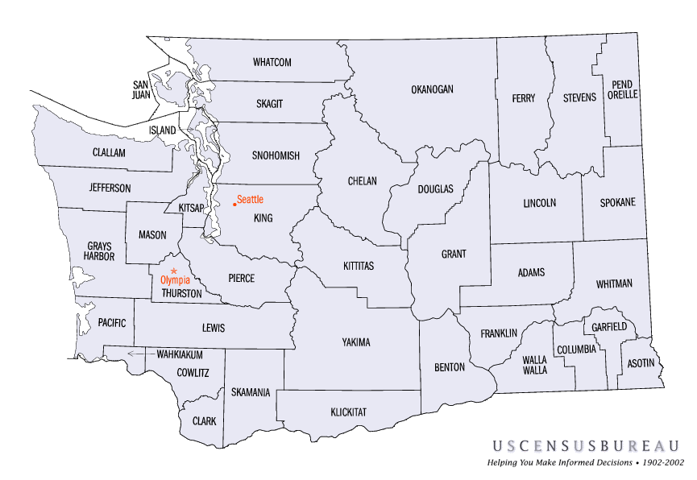

POSSIBLE SOURCES OF INFORMATION
WA State Department of Agriculture
US Department of Agriculture
WA State Commodity Commissions
Grower and Producer Websites

FOR MORE INFORMATION
Washington State 4-H Fair
2606 W. Pioneer
Puyallup, WA 98371
253-445-4630 (until Aug 15)
253-770-5410 (Aug 15 to Sept 30)
Email: st4hfair@wsu.edu
Website:
http://extension.wsu.edu/4h/fairs/state-4-h-fair

WASHINGTON
STATE 4-H FAIR

COMMODITY
PUBLIC
PRESENTATION
PROGRAM

2017

