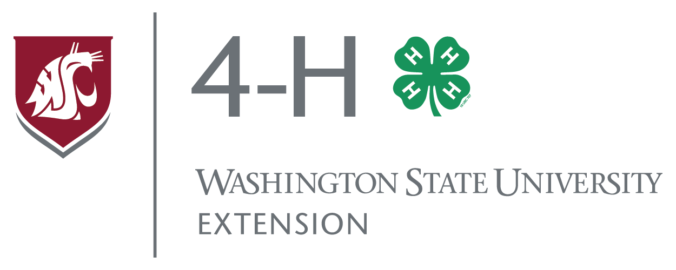
Chartering a 4-H Club
in Washington State

The 4-H Youth Development Program is the nation's largest non-formal, out-of-school, inclusive youth development program. The 4-H Name and Emblem are federally protected (18 USC 707) as the official trademark of USDA for Extension youth development education in land-grant systems. The National 4-H Headquarters, with state 4-H Program Leaders and County 4-H staff, are designated by the Secretary of Agriculture to recognize and charter groups to function under the 4-H educational mission.

The youth development mission of the 4-H Program is achieved through partnerships with approved volunteers who are critical in providing high quality 4-H club experiences for youth. Volunteers also serve as role models, mentors, and guides for youth. Because youth develop over time, 4-H clubs that meet regularly can provide youth with a variety of age-appropriate experiences they need to thrive and reach their full potential.

A 4-H Club Charter allows a group to use the 4-H Name and Emblem. The Charter documentation provides communication, education and accountability. Once a Charter is granted, the rights and responsibilities of 4-H partners (club members, volunteers and staff) remain consistent.

Rights and Responsibilities of a Chartered 4-H Club
When a 4-H club agrees to function within the high standards assigned to the national 4-H Name & Emblem, then 4-H staff will issue a Charter which formally grants:
- Authorization to use the 4-H Name & Emblem in accordance with its educational mission (including an option to raise, allocate and disburse funds within those guidelines)
- Inclusion under the tax exempt group ruling for Washington State 4-H Youth Development
- Compliance with submission of annual reports as required by the Washington State 4-H Youth Development Program
- Adherence to the Washington State 4-H Youth Development Policy as a club National 4-H Fact sheets: "Charters: The Key to Official Recognition” 2008

Quality 4-H Programming
WSU Extension staff and 4-H volunteers have access to education and resources for the purpose of providing high quality 4-H programs. Together, they implement 4-H programs to help youth:
- Belong to a group that develops positive relationships with peers and adults.
- Find their spark; and develop and master skills for a successful transition to adulthood.
- Be generous and contributing citizens through community involvement and service.
- Practice independence through decision-making in a consistently, safe environment.
- Be actively involved (planning, doing, reflecting) and challenged in their own learning.
- Have fun!

WSU Extension programs and employment are available to all without discrimination.
Evidence of noncompliance may be reported through your local Extension office.

Standards for a Chartered 4-H Club
Together, 4-H youth and volunteers review, date, and/or check (✓) the following statements to apply for a 4-H Club Charter. Return these pages (2 and 3) to 4-H staff at the local county Extension 4-H Office.
*4-H staff will monitor status of items checked (✓) 'in progress' for accomplishment in reasonable time.

NOTE: A group MUST have a Charter before using the 4-H Name & Emblem or conducting financial business.

1. 4-H Club Organization
Date Completed Agreed
__/__/__ __ A. To establish a welcoming place to learn, we agree to choose a club name that is inclusive, and does not discriminate against any interested youth (inclusive without regard to race, color, religion, national origin, gender, disability, sexual orientation, or marital/parental status) today or in the future. Youth from historically underrepresented groups are welcome in 4-H. Upon verbal approval by the local WSU Extension 4-H staff, the name of this 4-H club/group is: _________________________________________________________________________

__/__/__ __ B. The 4-H Name & Emblem is protected by Federal law. This 4-H Club agrees to read and understand how to use the 4-H Name & Emblem appropriately. See National 4-H Fact Sheet "Use of the 4-H Name & Emblem."

__/__/__ __ C. To expand and practice healthy relationships beyond one's family, this 4-H Club agrees to establish the goal to recruit and enroll at least five (5) members from at least three (3) different families to participate.

2. Club Meetings and Education
__/__/__ __ A. We will participate in a minimum of six (6) hours of planned, group activities, meetings, service, workshops to qualify as 4-H programming.

__/__/__ __ B. We will support an ongoing, positive learning environment, we will schedule a minimum of six (6) club meetings during a 4-H year (which is Oct. 1 - Sept. 30).

__/__/__ __ C. To provide quality 4-H programming and help youth thrive, 4-H club meetings will
include: business (led by members), education, and fun.

__/__/__ __ D. To help youth practice decision-making in a safe environment, 4-H clubs often choose ‘officer’ and committee roles to practice decision-making and leadership skills in 4-H. Each club may choose ways for youth to practice these skills. This group will: _____________________________________________________________________ _____________________________________________________________________
__/__/__ __ E. To make sure that we all have a sense of ownership of our group we will have written guidelines (like a constitution and bylaws) that all group members approve.

WSU Extension programs and employment are available to all without discrimination.
Evidence of noncompliance may be reported through your local Extension office.

3. Fundraising under the 4-H Name & Emblem
__/__/__ __ A. lf our club chooses to do fundraising or maintain a treasury, we agree to:
(1) Utilize a bank account identifying WSU 4-H “Club Name” as the owner of the account
(2) Submit our intent to raise funds to County 4-H staff (at least 2 weeks prior to fundraising) as part of annual “program of work”
(3) Follow the established protocol for conducting fundraising and submitting reports (see C1059E)

4. Adult Supervision
__/__/__ __ A. For safety, this 4-H Club is supervised by certified and enrolled 4-H volunteers who
have been screened and trained by the WSU Extension Office.

__ B. All leaders serving in this club will be enrolled and have signed the C1000 Valuable
Partnership, and have access to the Statewide 4-H Program Policy.
The Primary Organizational Club Leader is:
__________________________________________________________

5. Actions of 4-H Club/Group
__/__/__ __ A. Things this club will do to help others know that we are welcoming, safe and fun, are:
____________________________________________________________
____________________________________________________________

6. When Could a Club Charter be revoked?
__/__/__ __ A. We understand that a 4-H Charter may be revoked by the WSU 4-H program Leader if
the club knowingly and consistently (1) creates an unsafe or unhealthy environment for participants; (2) uses the 4-H Name & Emblem inappropriately; (3) functions in a discriminating manner; (4) no longer meets the criteria of a 4-H Club; or (5) fails to adhere to Washington State 4-H Policy.

7. Signatures of two (2) 4-H Club Officers or Members
A. ______________________________________________________ Date: ____________
B. ______________________________________________________ Date: ____________

8. Signatures of two (2) approved 4-H volunteers
A. ______________________________________________________ Date: ____________
B. ______________________________________________________ Date: ____________

Thank you for being an important part of the WSU 4-H Program
County 4-H Office files original charter and will send a copy and Charter Certificate to Club
WSU Extension programs and employment are available to all without discrimination.
Evidence of noncompliance may be reported through your local Extension office.

