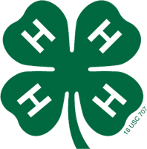
4-H Informational Posters and Educational Displays

Posters vs. Displays
 | Posters | Displays
Purpose: | Grab viewers’ attention and teach them something in less than one minute | Grab viewers’ attention, teach them something, and hold their attention for a longer period of time
Size: | 14”x22” minimum in Jefferson Co.  or regular 22”x”28 works best | Multiple posters, a tri-fold display, mobile, charts, or 3D display
Viewing Distance: | 10 feet or more | 3 feet or less
Content: | ONE clear thought | Multiple thoughts on one subject

Choosing Your Idea
- From your 4-H meetings, research-rich books and websites, 4-H publications
- Sources must be CREDIBLE and ACCURATE (not “opinions” or speculation)
- Keep it simple and focused – don’t overthink your subject!

Posters
DO: | DON’T:
Attract attention | Repel viewers or blend in with the wall
Focus on ONE main interest or idea | Overcomplicate your message
Stimulate thought | Put viewers to sleep or confuse them
Teach facts or show a simple process | Express a personal opinion
Use few, clear, easy-to-read words | Use lots and lots and lots and and lots and lots of words with very tiny and fancy and distracting fonts or pOor hAnDwriTing
Use clear images, fonts, and handwriting; good spelling and grammar; a boarder; and clear and compelling images | Use GLITTER or copyrighted materials/images (e.g., well-known cartoons); forget to spell-check; forget to erase pencil lines
Be neat | Be sloppy
Be colorful (within reason) | Use no color or colors that can’t be seen easily (e.g., light yellow on white poster board)
Make a rough draft of your poster | Just grab some posterboard, a Sharpie, and go for it!
Attach all items securely | Lose your poster bits on the way to fair!
Create your poster yourself – even if you use computer-generated lettering and/or images | Have your big brother, grandma, or sign shop make your poster for you
Make sure your poster can hang on a wall (i.e., not too heavy) | Put your poster in a frame or plexiglass; use foam-core board
Simply tell your audience something you’d like for them to know | Use the phrase: “Did you know?”

Posters at Jefferson County Fair:
- Your poster will be related to your current project area(s) (e.g., poultry, robotics, horses, etc.)
- You may enter up to 2 posters in up to 3 different project areas
- You may also enter 1 project safety poster and 1 4-H promotion poster
- Put your name, date of birth, and county on the back of your poster
- Bring your poster to the fairgrounds Monday Aug. 7, 2017 (or have someone in your club do it for you)
Educational Display Scorecard
This is the “scorecard” that Judges use to evaluate 4-H Posters and Displays.
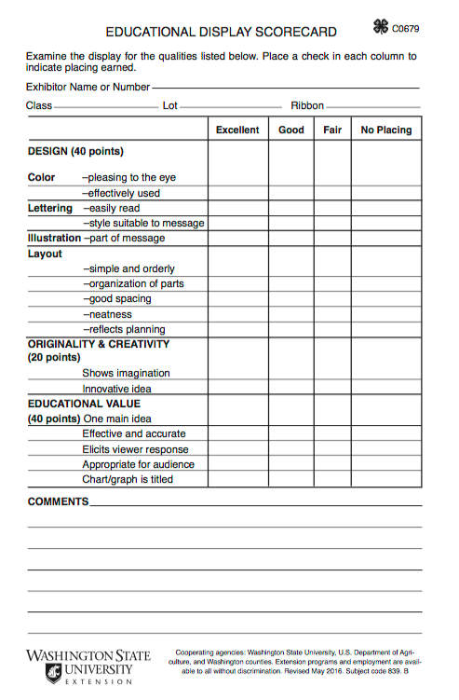
Have a look over it to be sure that you know what judges are looking for in your poster or display.

The more “excellents” a poster or display receives, the more likely it is to get a Blue ribbon. More checkmarks in the “good” category earns the poster/display a Red, and more checkmarks in the “fair” category earns it a White. More checkmarks in the “no placing” category means that the poster/display will receive a “participation” ribbon.

What do the ribbon colors mean?
- Blue: The exhibit meets standards and expectations of the project. The exhibit shows high-quality work and needs little or no improvements. Excellent exhibit.
- Red: The exhibit meets most standards and expectations of the project. The exhibit shows high-quality work; however, some improvements can be made in workmanship, design, or expression of what was learned in the project. Good exhibit.
- White: The exhibit meets few standards and expectations of the project. The exhibit can be improved in workmanship, design or knowledge shared about the project.
- Green/Pink/Rainbow: Recognition of the efforts of all Cloverbuds and participants.

Examples of Blue-, Red-, and White-Ribbon Posters
Look at the posters below and learn why they received a blue, red, or white ribbon.
Do you think the judges had it right?
