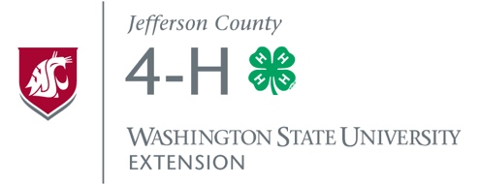
JEFFERSON COUNTY 4-H
YEAR-END AWARD REQUIREMENTS

SPECIAL NOTE: 4-H Main Club/Program Leaders must submit 1) leader-completed “Year-End Pin” forms, 2) youth-completed Record Books, and/or 3) any other award application materials for their members no later than SEPTEMBER 30 to the 4-H/WSU Extension Office.

Youth Year-End Pins
Jefferson County 4-H members completing the following goals will receive a 4-H year-end pin:
- Attend most 4-H Club/Program meetings (please notify leader of any absences).
- Participate in at least one 4-H Community Service activity.
- Participate in at least one 4-H Council-sponsored event/activity.
- Give a public presentation/demonstration at a Club meeting, Spring Presentation event, and/or County Fair.
- Participate or exhibit at the Jefferson County Fair.
- Complete and turn in a Record Book. (Youth should turn in completed Record Books to main Club/Program Leader before September 30, in order to allow Leaders time to review books prior to submitting to the 4-H/WSU Extension Office.)

Cloverbud members (ages 5-7) only need to complete five of these six requirements.

Adult Year-End Pins
In order for an adult Leader to receive a Leader, year pin, he/she must be enrolled as a 4-H Volunteer. Only Leaders completing their 5th, 10th, and 20th years may receive pins. Main Club/Program Leaders must turn in a completed “Year-End Pin” form listing eligible youth and adults to the 4-H/WSU Extension Office no later than September 30.

County Project and Activity “Medals”
County Medals are giving in most 4-H project and activity areas (e.g., Horse, Clothing & Textiles, Public Presentations, Leadership, Robotics, etc.) based upon a 4-H member’s exceptional participation and commitment throughout the year. To be eligible for a County Medal, a member must have earned their 4-H Year-End Pin first. Leaders fill out “Project/Activity Recognition” forms and turn in to 4-H/WSU Extension office by September 30.

Revised and Approved by Jefferson County 4-H Council
January 4, 2016

