All Friendly Dogs Welcome
(Mixed Breed & Purebred)

Club members have a lot of fun with their dogs as they learn and develop leadership, citizenship, & life-skills.

Membership in 4-H

Any girl or boy, ages 5-19, can join 4-H.

Primary | grades K – 2
Junior | grades 3 – 5
Intermediate | grades 6 – 8
Senior | grades 9 – 12

The 4-H year is October to September.

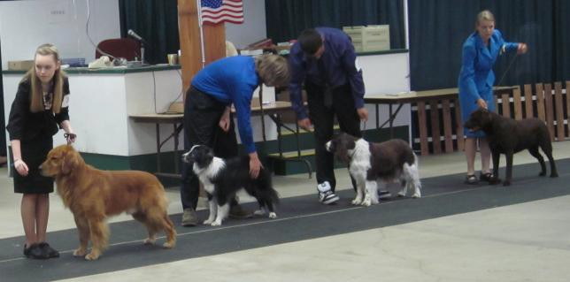New members can register at any time for low-cost, family fun. To participate in the King County Fair, join by May 1st.
Washington State 4-H Dog Project Objectives

Enjoy and benefit from the experience of being an active member of a 4-H club and experience the pride of owning & showing your 4-H dog as you:
Learn
- Cooperation as one part of a dog & handler team and by sharing your experiences with others
- To accept the judge's decision gracefully
- To show and handle dogs safely
- To work with other 4-H members
- To keep good records and to use them to make management decisions
- Show ring rules and etiquette
- To be courteous to the public, judges, show and fair officials, and other competitors
- To care for and manage a dog
Develop
- Leadership, initiative, sportsmanship and responsibility.
- Self-reliance and patience by working with your dog daily.
- Public speaking skills by expressing your ideas before groups in demonstrations, judging contests, and other activities.

http://4-h.wsu.edu/projects/dog.htm
Kids—Join a club!

Current King County Clubs

Auburn Valley Tailwaggers  Ponytailsranch3@aol.com | Auburn  Monday
Dawg Gone Dogs scodeb444@hotmail.com tiffiney@live.com | Federal Way  Tuesday
Eastside Hushpuppies  hartbult@aol.com | Bellevue  Tuesday
Seattle Power Paws  carol-als@comcast.net | Seattle  Tuesday
Sirius  sarakranch@gmail.com | Enumclaw  Tuesday
Are you interested in working with youth?
Have a love for dogs?
Adults—start
a club of your own!
King County 4-H Dog Project is always looking for new club leaders.
Guidance and mentoring provided for ALL interested adults. Individuals DO NOT have to have children in 4-H.
If you enjoy working with kids and dogs, please contact the King County Extension Office!

