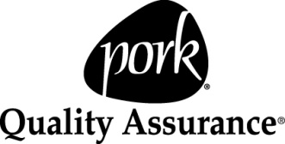


Producer Affidavit &
Market Swine Health Record
Youth Producer:
Name:
Address:

Premise ID (if available):
Phone:
QA Certification #:
Fair:
Fair Tag #:
Sale Date:

Producer Affidavit and Animal Information (Obtain from producer):
Herd Tag #/ Ear Notch ID:_______________________________ Sex:
Birth Date:____________ Breed/Color:
I (original producer) attest through first-hand knowledge, normal business records, or producer affidavit(s) that the animal referenced to by this document is of ___________ (country) origin, and is delivered to _____________________________________________________________ (Youth Producer).
Date Purchased: ______________ Premise ID (if available):
Purchased From (Farm Name): ______________________________ Office Phone:
Address: __________________________________ City, State, Zip:

Producer Signature: _____________________________ Print Name:
C1055E

Youth producers only list treatments administered while under your care. Do NOT list treatments administered prior to purchase.
If you need additional space for treatments or medicated feeds, use supplemental health form page—available at animalag.wsu.edu-“Youth Producers”.

Treatments & Dewormers  (Date & Time) | Condition Being Treated | Estimated Weight | Treatment Administered (Medication dispensed, amount, and route of administration) | Drug Lot Number | Name  (Person giving treatment) | Withdrawal Time (Instructed) | Withdrawal Complete (Date & Time) | For prescription or extra label drug use, list the veterinarian’s name, address, and phone.

Medicated Feeds: Remember to document ALL medicated feeds and withdrawal times.
“Produce healthy and safe pork products by being a knowledgeable and responsible producer.”

Dates Fed | Medication Name  (Medication included in feed and approximate amount of medication) | Withdrawal Time (Instructed) | Withdrawal Complete (Date & Time)

Give Subcutaneous (Sub-Q) injections under loose skin of neck or flanks, using the tented method. Give Intra-muscular (IM) injections in the neck. If label indicates a choice, use Sub-Q (under the skin) injections over IM.

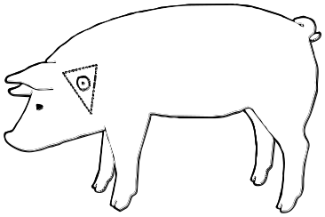

NEVER
inject into the ham or the loin area.
I certify that I produced this animal and I have listed ALL products and treatments they received while in my care/ownership and all withdrawal times have been met. I attest that the animal referred to by this document is of ___________(country) origin and raised in _____________ (country).
Youth Signature:_____________________________________________________Date:___________
Guardian Signature:__________________________________________________Date:___________
WSU Extension programs and employment are available to all without discrimination. Evidence of discrimination may be reported through your local WSU Extension Office.
Authors: Sarah M. Smith, Jean Smith, and Jan Busboom.
C1055E revised November 2008.

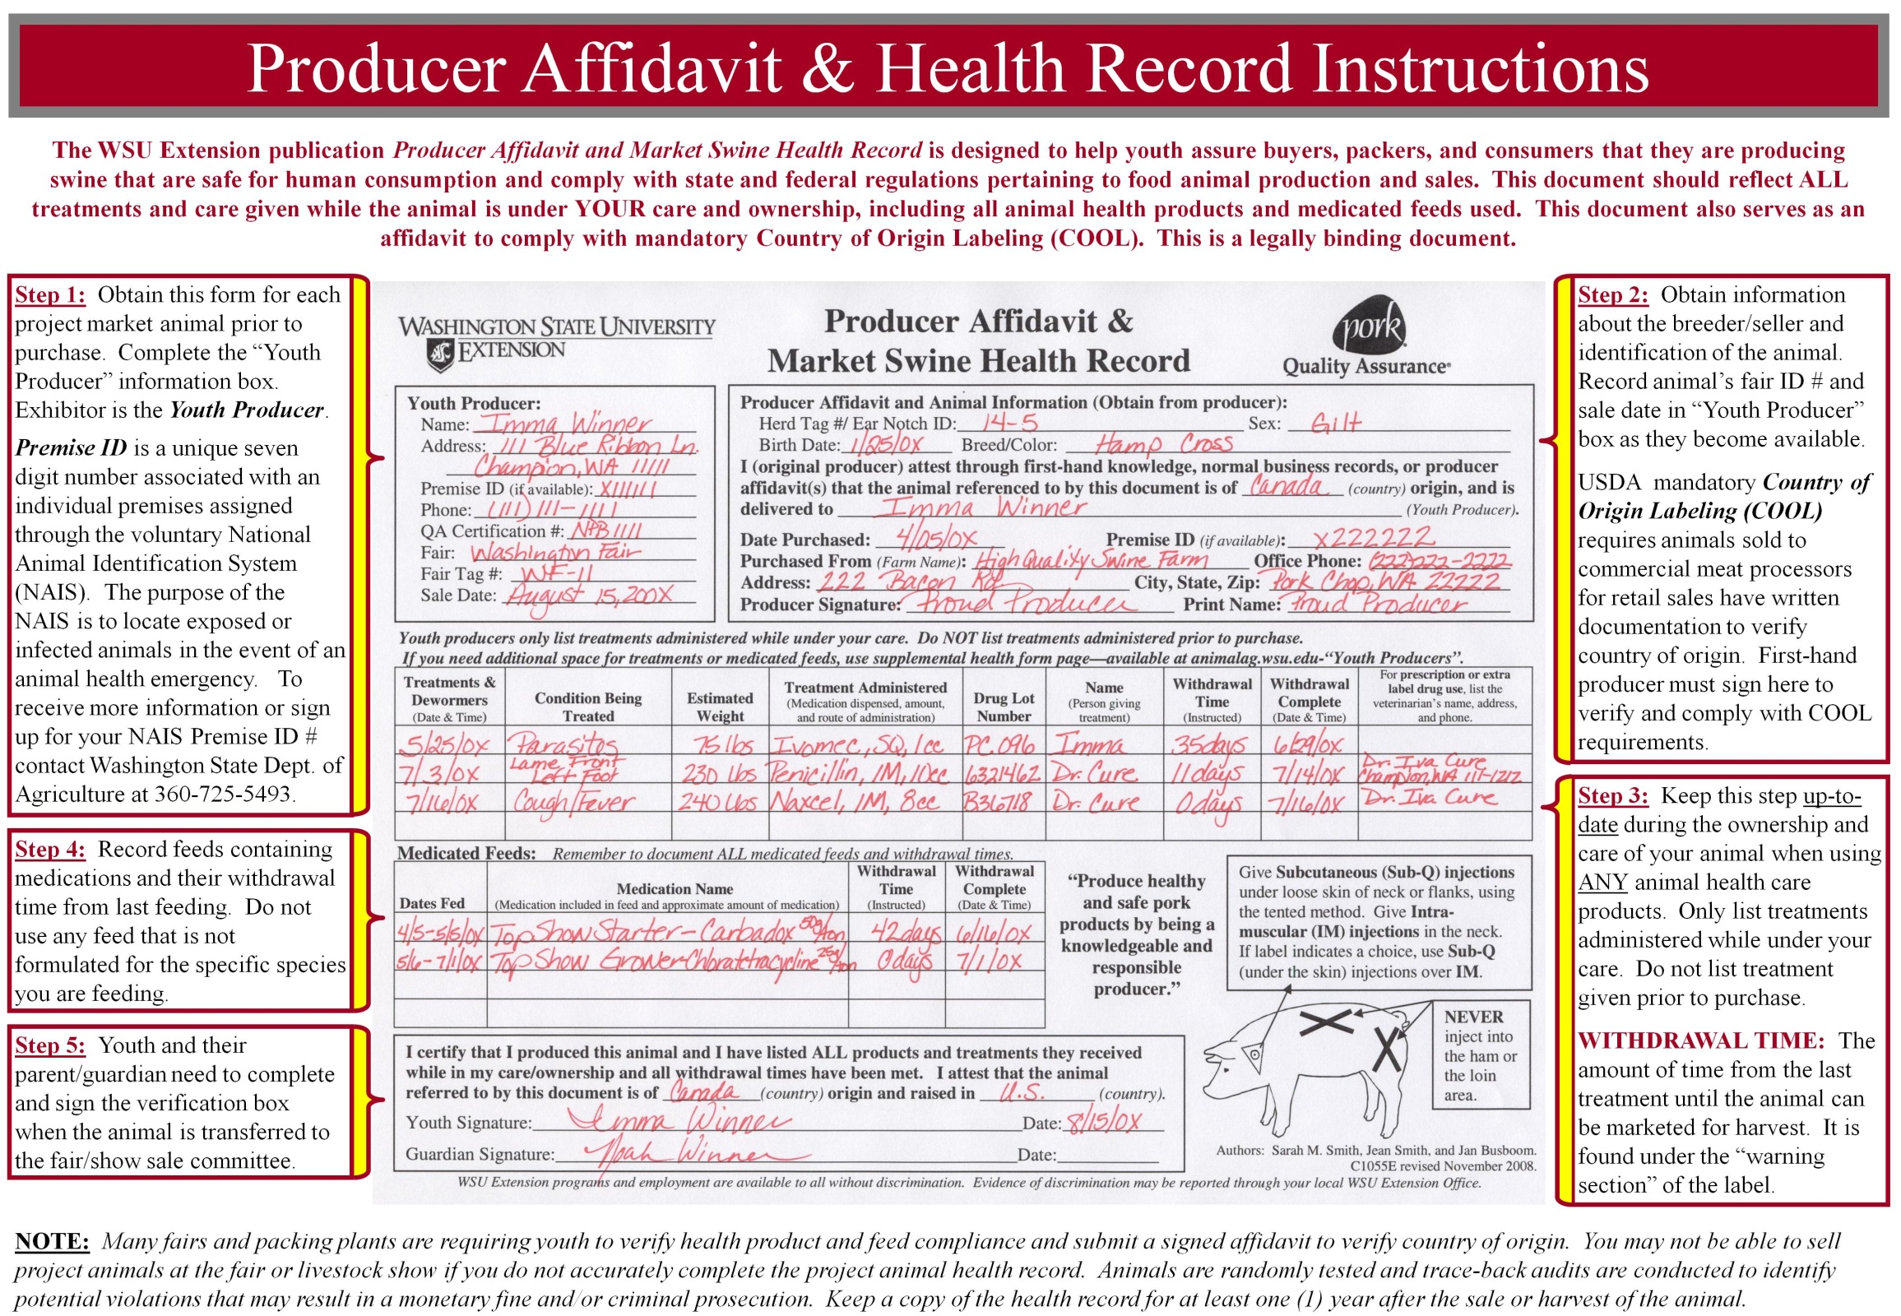
The information given herein is for educational purposes only.
References to commercial products or trade names are made with the understanding that no discrimination is intended and no endorsement by WSU Extension is implied.

