NOXIOUS WEEDS IN
SAN JUAN COUNTY FORESTS:
A BRIEF GUIDE.

San Juan County Noxious Weed Control Program/WSU Extension
62 Henry Rd. #26, PO Box 1634 Eastsound, WA 98245 (360) 376-3499
http://extension.wsu.edu/sanjuan/noxious/

Introduction.
Forest owners and managers have a variety of environmental considerations to contend with when undertaking logging operations or woodlot management, such as protecting water quality, preventing soil erosion, reducing wildfire risk, and providing wildlife habitat. The control of weeds—noxious weeds in particular—probably doesn’t come to mind, at least prior to harvest. But state law (RCW 17.10 and WAC 16-750) mandates the control or eradication of certain state-listed noxious weed species, including some that can be detrimental to forests. This guide acquaints San Juan County residents interested in forestry practices with some of the species they might encounter, as well as some of the ways these plants can be controlled.

What Is A ‘Noxious Weed’?
In the state of Washington, a noxious weed is legally defined, under RCW 17.10.10, as “a plant that when established is highly destructive, competitive, or difficult to control by cultural or chemical practices” (Washington State Noxious Weed Control Board).

Noxious Weed Classes.
- Class A - consists of those noxious weeds not native to the state that are of limited distribution or are unrecorded in the state and that pose a serious threat to the state. Eradication required.
- Class B - consists of those noxious weeds not native to the state that are of limited distribution or are unrecorded in a region of the state and that pose a serious threat to that region. Control may be required.
- Class C – consists of any other noxious weeds (generally considered more common). May be selected for control at the county level.

The forest land owner has the duty to eradicate Class A weeds. Classes B and C noxious weeds designated by the state or selected by the county must be controlled (prevent them from spreading within or beyond that property). Selected Class C weeds, however, are only required to be controlled on designated forest lands within a one-thousand-foot buffer strip from adjacent land uses (RCW 17.10.140 (2)). Yet during a single five-year period following harvest for lumber, an owner of forest land must control all county-select Class C species as well.

The IVM ‘Tool Box’.
Integrated Vegetation Management (IVM) takes a variety of approaches to control troublesome plants. The first step in any IVM program is to know your plants and their biology. What is the weed in question, its preferred habitat, and how does it reproduce and spread?
- Prevention -- truly the most economical way to deal with noxious weeds but requires awareness by the forest owner or manager. Examples include: cleaning equipment prior to entering or leaving forest land; using weed-free seed or mulch in revegetation; minimizing soil disturbance; and acquiring clean aggregates for road-building.
- Cultural – overlaps with prevention: planning to use non-invasive post-harvest plant materials and clean mulch to suppress weed seedlings; maintaining shade; burning.
- Biological – can mean the use of livestock to browse weeds, or carefully selected insects or diseases that specifically target a particular noxious weed species (“host specificity”).
- Manual/Mechanical – the use of hand- or power tools such as shovels, weed wrenches, mowers or one’s gloved hand to control weeds.
- Chemical – herbicides, either systemic or contact, ‘naturally-derived’ or synthetic, may offer a choice of last resort for certain extremely difficult species.

Spurge Laurel
Daphne laureola, Class B
Control Required.
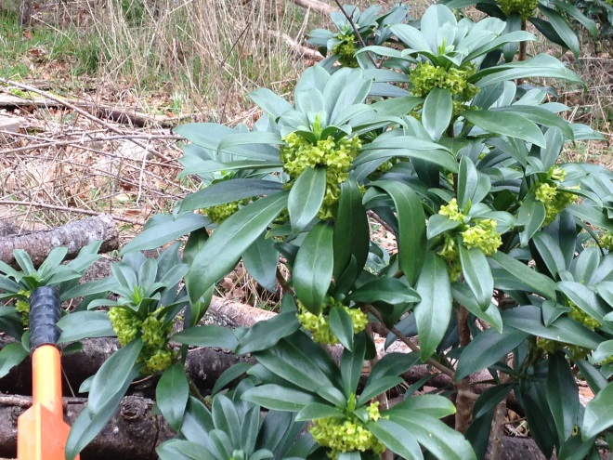
This evergreen shrub was introduced as a garden ornamental and blooms in the wintertime. If left unchecked, it may eventually take over the forest floor, outcompeting native vegetation. Irritating toxins in the leaves, fruit, stems and sap require the use of gloves and protective clothing when handling. Small plants can be pulled up by the roots when the ground is moist. A weed wrench is effective for larger shrubs, or use a mattock or shovel to cut the roots at least two inches below the soil surface. Spurge laurel spreads to new locations via birds, who consume its ripe, black berries. The best time to control it is in the Fall/Winter. Mechanical control with a weed trimmer is not recommended due to the volatilization of the toxins, which can cause severe irritation to exposed parts of the body (eyes, skin, respiratory tract), and stump-sprouting is likely.

Old Man’s Beard
Clematis vitalba, Class C
Control Recommended.
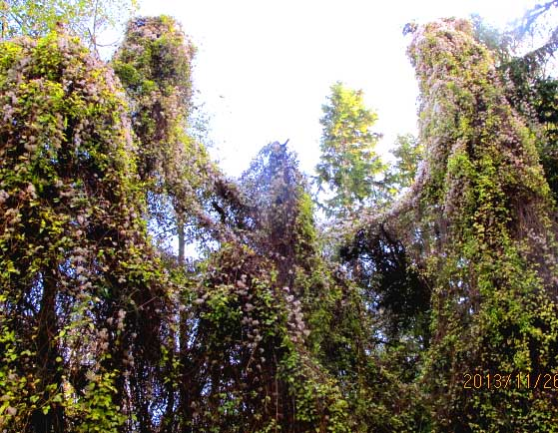
This woody, ornamental vine has escaped cultivation in a big way, especially near Eastsound, where it is engulfing neighborhood forests. It can grow as much as 5 meters in a single year, and its seeds spread by air, water, animal, or machinery. A 0.5 square-meter area may produce as much as 17,000 viable seeds per year (WSNWCB). Engulfed trees may eventually collapse and are a significant hazard. To remove from trees, use loppers or hand saws to cut vines at ground level and again several feet up (stem or root fragments can re-root if in contact with moist soil). Danger: do not pull cut vines from trees due to risk of falling limbs. Use a shovel or Pulaski to dig up the base, or pull by hand if the plant is still small. Grazers like sheep can consume young seedlings and young vines at ground level. A cut-and-paint approach with a systemic herbicide can be very effective (aminopyralid, imazapyr, glyphosate), applied to the outer ring of the cut surface (cambium) immediately after cutting, best when done in the early fall.
English Ivy
Hedera helix, Class C
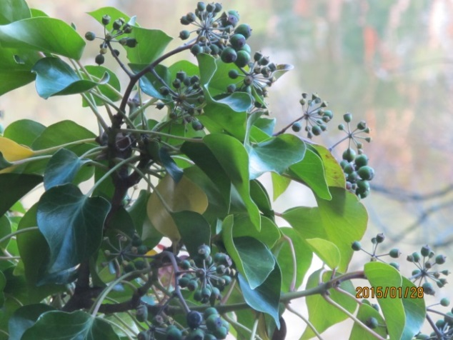
Control Required.

Many gardeners love English ivy as a ground cover, but the Washington State Noxious Weed Board considers four cultivars to be noxious (this includes H. hibernica). The main task for forest lot owners is to keep the vines from climbing trees, where they can produce flowers and seeds that will be spread by birds to new sites. The sheer mass of ivy vegetation in a tree’s canopy can increase the likelihood of windthrow during winter storms. Control techniques are much the same as for old man’s beard (Clematis vitalba). Cut vines at the base of all trees and several feet up, stripping them from the trunk. Ground ivy can be cut and rolled up like a carpet, grubbing out the roots along the way. Island deer are known to browse ivy on the ground, often stripping the leaves. Herbicide options include triclopyr amine (Brush-B-Gone, Brush Killer), used full-strength for cut-stem applications (within 5 minutes of cut), or glyphosate (at least 41 % a.i). Caution: vines may re-root if in contact with moist soil, and ivy can irritate the skin for some people.
English Holly
Ilex aquifolium, State Monitor List
Control Recommended.
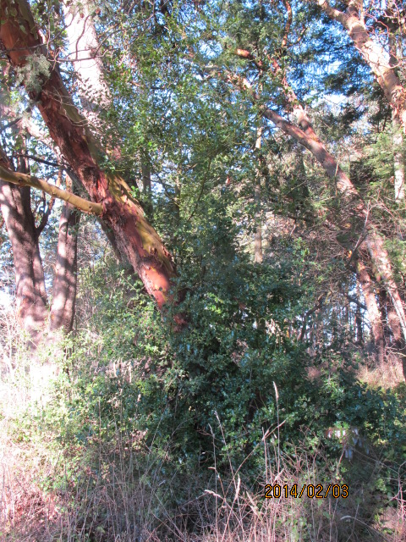
This ornamental, non-native evergreen tree or large shrub nearly made the noxious weed list but was vigorously championed by the state’s holly growers association (it continues to be sold at plant nurseries). Nonetheless, the uncontrolled spread of English holly is a considerable threat to forests of western Washington, suppressing native vegetation at the ground and middle canopy. It can spread by seed (birds consuming the red berries) or vegetatively if the tree is damaged or disturbed (adventitious shoots can form from lateral roots). Small plants can be removed by pulling or digging. Larger specimens, unless they can be removed in their entirety with heavy equipment, will have to be treated with herbicides. Cut-stump or frilling application with triclopyr works well, either spring or fall. Stem injection with imazapyr works even better (EZ-Ject lance). If you cut the tree down without herbicides, expect stump-sprouting and potentially many new plants along the root system.

English Hawthorn
Crataegus monogyna, Class C
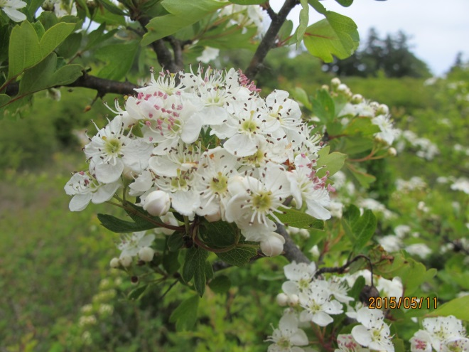
Control Recommended.
English hawthorn, yet another introduced ornamental, also served as a handy hedgerow for early farmers, who could keep their livestock better contained due to its sizeable thorns and dense growth. The worst infestations are found in parts of San Juan Valley, where acres of former pasture are now solid hawthorn. Doug McCutcheon of the Land Bank says that this species is one of the most dangerous trees that he works with. Though it is still widely admired for its beautiful flowers and bright red berries, which are also said to be medicinally useful, English hawthorn can, in heavy infestations, prevent most other land uses, including commercial forestry. In Europe and New Zealand, this species hosts a fire blight bacterium which can infect apples and pears (WSNWCB). Like holly, smaller plants can be removed when the soil is moist (a weed wrench or by hand). Mowing is generally ineffective but can buy time and prevent fruit set. Some islanders have used heavy machinery to clear large patches, but the resultant disturbance to the soil may produce many new seedlings, especially if done when ripe berries are present. As with holly, it is best to avoid cutting down hawthorn as a stand-alone treatment, given its ability to stump-sprout and produce new shoots from its root network. In Multnomah County, Oregon, there has been success using cut-stump or frilling with triclopyr (amine formulation).

Canada Thistle
Cirsium arvense – Class C
Control Recommended.
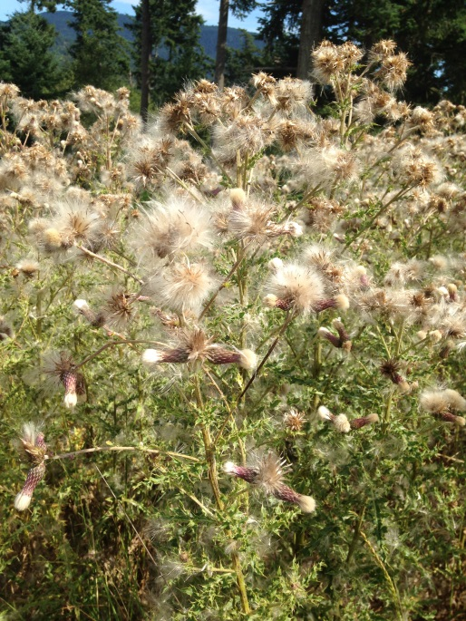
This non-native perennial was probably introduced to North America as an agricultural contaminant, and it is one of the more common noxious weeds in our forest lands following logging. Canada thistle can spread by seeds that are carried by wind, wildlife, or contaminated machinery. Once established, it can also expand vegetatively through its roots and underground stems called rhizomes: a single, large patch may actually be one clonal mass. If cultivated, Canada thistle even grows anew from root fragments as small as 1/8 inch—truly a resilient species. Repeated cultivation can work if done every 7 to 28 days during the growing season, as can mowing or pulling plants by hand when it is in the tight bud stage before flowering (repeat as necessary). Cultural control is said to work quite well if competitive forage grasses or forbs like alfalfa are planted. Biological controls include the stem gall fly (Urophora cardui) and goats or other livestock who may eat younger shoots, flowers or foliage if better forage isn’t available. Systemic herbicides that do not harm grasses work well, especially when applied in the early fall when the soil is moist and plants are still growing.

Bull Thistle
Cirsium vulgare – Class C
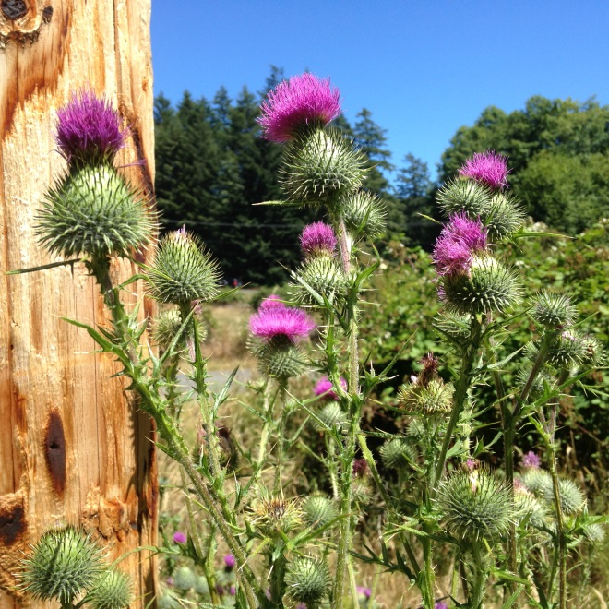
Control Recommended.
Introduced from the Old World, bull thistle is a biennial, spending its first year as a rosette. Come spring, it sends up a flowering stalk with sharp spines and deeply lobed leaves. Seeds can lie dormant in the soil for many years, which can germinate in large numbers in recently harvested forests even when disturbance is relatively light (dormancy may be released by changes in light and/or soil temperature). If infestations are small, control can be fairly straightforward. Rosettes can be removed manually, getting most of the taproot. If pulling or digging the flowering plants, flowers should be bagged and disposed of or burned (prevent seed from spreading by wind). Mowing can work if the plant has bolted (sent up a stalk) and in the tight bud stage, but if done too soon, the plant will merely flower again. Like other members of the Asteraceae (sunflower family) bull thistle flowers, even if cut before opening, can ‘after-ripen’, producing viable seeds. Biological controls are similar to Canada thistle: a seedhead gall fly (Urophora stylata) may be available for distribution in long-term stands. Except for goats, livestock herbivory is less of an option due to the spines, but others are known to eat the flowers. Cultural practices include the use of a thick mulch (wood chips) or promoting shade (a closed canopy), and planting competitive grasses or forbs. Very young rosettes may be killed with a weed torch. Broad-leaf systemic herbicides that don’t affect grasses can be used for spot treatments.
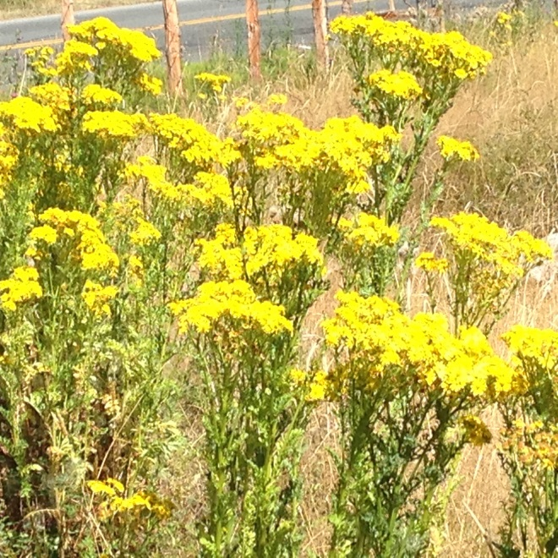

Tansy Ragwort
Senecio jacobaea – Class B
Control Required.
Like the thistles, tansy ragwort is a member of the sunflower family (Asteraceae) whose seeds can spread quite easily by wind, wildlife or contaminated machinery. Many parcels that have been recently logged or cleared for home construction have an abundance of tansy, undoubtedly some of it brought in by dirty equipment. One of our SJC Noxious Weed Board members, who has lived on Orcas her entire life, observed that tansy ragwort first appeared there following the great windstorms of 1989-1990, when thousands of trees blew down, and mainland crews of loggers arrived to clear the roads.

The main concern about tansy is that it is toxic if consumed: metabolized alkaloids cause liver damage in animals (including humans) and can contaminate the food chain (honey, milk, flour). If you already have it on your forest land, try to minimize equipment travel within infested areas. If this is unavoidable, be sure to clean machinery before moving into clean areas. Tansy ragwort is typically a biennial, with a first-year clump of frilly leaves, and second-year flowering (see previous photo). If the infestation is manageable in size, the easiest manual way to deal with it is to pull plants when they have bolted, preferably before flowering. If in flower, be sure to cut off the flowers and bag them for disposal once the plant is removed (easier when the soil is moist). If left on the ground, the flowers can after-ripen, and given the seeds’ potential longevity (up to 16 years), this is best avoided. Pulling or digging rosettes can also work, but greater care must be taken to remove the roots, since root fragments left behind can produce new plants. A pulled rosette can even re-root itself if left on a moist, soft surface.

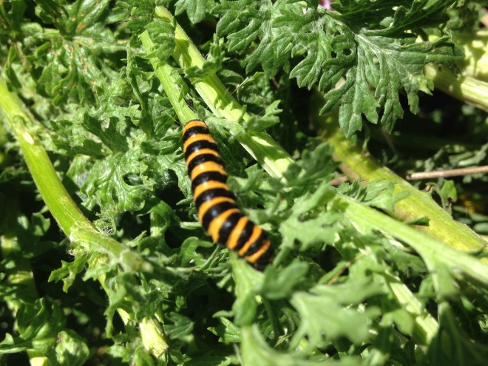
Mowing before flowering can help to suppress spread in larger patches but usually doesn’t kill the plants: they simply regrow and flower again. Combined with broadleaf, systemic herbicides, however, mowing can be a useful tool in reducing the amount of plant matter to deal with. Warning: cut or treated tansy ragwort may be more palatable once it is dried, so keep livestock away (sheep can be used to graze tansy ragwort, since they are not as susceptible to its toxins if consumption is moderate).

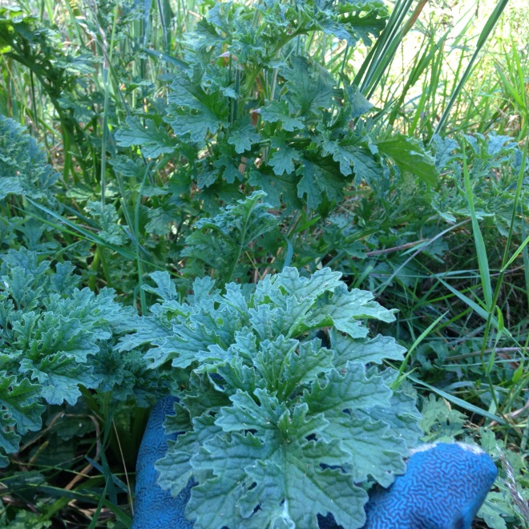
There are three main biological controls that have been introduced to the west coast: the cinnabar moth (Tyria jacobaeae), the ragwort flea beetle (Longitarsus jacobaeae), and the ragwort seed fly (Pegohylemyia seneciella). The cinnabar moth’s tiger-striped larvae are perhaps the most visible and best-known in our county, and they can do a remarkable job in defoliating flowering plants. Unfortunately, their effect is temporary: denuded plants usually re-flower later in the summer or early fall. As tansy requires sunlight and a disturbed habitat, the use of a thick mulch can suppress seedlings. In areas planted thick with grasses, tansy can have a harder time getting established, and seedling mortality may be high (WSNWCB).

Gorse
Ulex europeus – Class B
Control Required.
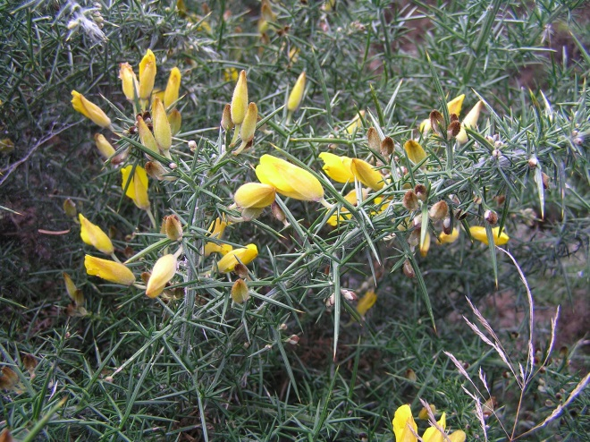
Considered by some to be one of the nastiest weeds, gorse leaves an unmistakable impression due to its numerous, long thorns and yellow, pea-like flowers. Though it is known more for infesting open grasslands or pastures, it can also survive in partial shade and is found in forested areas on Orcas Island, its only known home in the county. This non-native, evergreen shrub may take over the ground layer much like spurge laurel or Scot’s broom, forming dense, impenetrable thickets. Its volatile oils, which make it highly flammable, and its ability to stump-sprout mean that it can come back even from burned areas. Ejecting by force from pea-like pods, gorse seeds can broadcast up to 15 feet away from the parent plant (much like Scot’s broom), and may survive 30 or more years. The prevention of flowering is therefore highly desirable.

Whatever the combination of control methods used, follow-up monitoring and control will be necessary on an annual basis. For smaller patches, gorse can be controlled using saw, loppers and digging tools or weed wrench to wrest plants from the soil (get at least 3” below the surface). Use heavy gloves when handling gorse. The cuttings themselves can be left behind to help suppress new seedlings, or if desired, removed to a safe site to burn during the wetter months when permitted. Branches can also be chipped, but be sure to clean the chipper thoroughly before using elsewhere. For larger infestations, heavy equipment may be preferred. This approach, however, will disturb the soil to a much greater degree, leading to a potential flush of new seedlings following clearing. If conditions warrant, a weed torch can be a good tool in eliminating these seedlings.

On the biological front, younger shoots whose spines have not yet hardened can be browsed by livestock such as goats or sheep when the shoots are less than 3” tall. Using a brush hog or heavy-duty mower, shrubs can be shredded (mowing in the warmer months may have a better chance of killing the plants, but avoid doing so when the seed pods are ripe). The resultant stump-sprouted foliage can then be attacked with livestock or herbicides (systemic, broadleaf-specific preferred, but non-selective products with glyphosate and imazapyr also work well). Cut-stump application of triclopyr immediately following the cut has shown good results (perhaps best in early fall).

Scot’s Broom
Cytisus scoparius – Class B
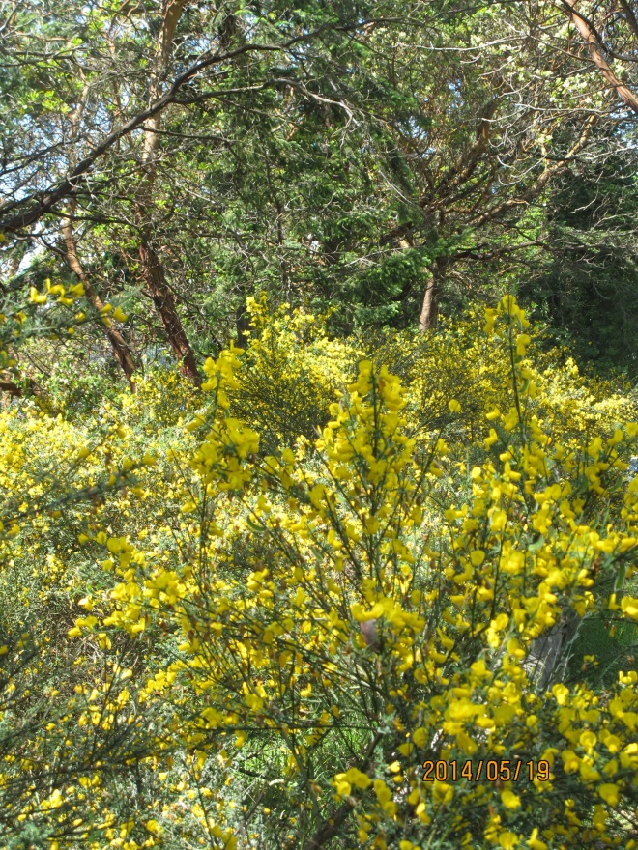
Control Required.
Introduced as an ornamental, Scot’s broom is more of a menace to foresters when trees are newly planted and small. Though it can tolerate some shade, broom is a sun lover and does best in meadows, roadsides and cleared forest lands. A recently harvested area that is re-planted can be subject to a storm surge of invasives: Scot’s broom can out-compete young Douglas firs for light and moisture and cause considerable losses. Particularly intense infestations can arrest forest succession for years, and like gorse, broom seeds can last many decades in the soil seed bank. These yellow-flowered members of the pea family are also flammable and may serve as “ladder fuels” in forest fires.

Fortunately, Scot’s broom can be controlled with reasonable effort. For smaller patches, one can use simple tools like a weed wrench, loppers or hand saw. The best time of year to work on it is around the time of flowering, when the weather is warmer and the soil drier. Try to remove broom before the seed pods turn brown or black. If you wait until the pods are mature, you may unwittingly spread the seeds far and wide, creating an even bigger problem. Small plants can be pulled out of the ground, while larger ones—at least one inch in diameter at the ground—can be cut as close to the ground as possible, even a bit underground. If cut too high, you risk re-sprouting from the stump, though the bigger ones may not come back if cut in the summer before pod maturity. One advantage of this technique is that it helps to minimize soil disturbance, so you’re less likely to see new seedlings coming back the following year (yearly monitoring will be needed, however). If cutting close to the ground isn’t possible, you can take a little more time to strip off the bark on the remaining stump.

For larger infestations, it may make more sense economically to resort to machinery like brush mowers or a metal-blade weed-trimmer. Mowing will often result in stump-sprouting (especially for smaller shrubs), but if timed during the drier months when plants are drought-stressed, it is possible that mortality would be high. Make sure to clean equipment prior to leaving broom-infested areas, and consider what will be planted in its place, since there will be a lot of bare ground that new weeds may invade.

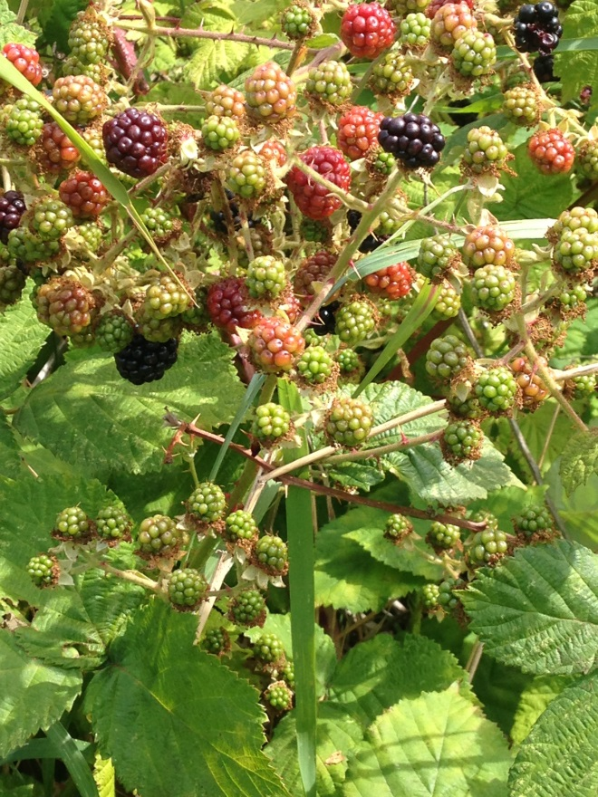
Biological controls for Scot’s broom include targeted grazing by goats. Two seed-feeding beetles, Bruchidius villosus and Exapion fuscirostre, have been introduced to our county and may suppress seed numbers. Another biocontrol, the broom gall mite (Aceria genistae), is occasionally seen in the county and can do considerable damage to Scot’s broom, even killing it. Herbicide techniques for Scot’s broom are similar to those of gorse. If mowing is performed beforehand, one can follow up with any stump sprouts by spot application with systemic products (triclopyr, imazapyr, aminopyralid, glyphosate). Cut-stump application can work as well but would have to be performed shortly after the cut.

Broom cuttings can be chipped in place, burned, or left to decompose (in a shaded location if you are worried about seeds).

Himalayan Blackberry
Rubus armeniacus – Class C
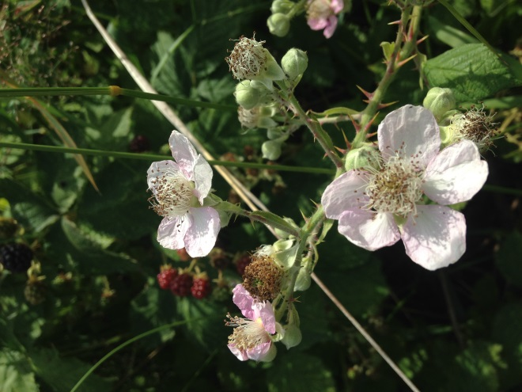
Control Recommended.
This formidable opponent is well-loved by many in our county due to its abundance of fruit and the provision of forage for honeybees, but Himalayan blackberry and its cousin, evergreen blackberry, R. laciniatus, have taken more than their fair share of the landscape, even in open or deciduous forests. Birds that eat its berries can spread blackberry to new locations, and established clumps can expand outwards with sprawling canes that are capable of forming roots if in contact with the ground.

One will need stout gloves and protective clothing when working with Himalayan or evergreen blackberry. For smaller patches, one can use loppers or machete to cut back canes enough to reach the root crown (base) of the plant, which can be uprooted with a shovel, mattock, rock bar or weed wrench. Try to get larger roots out as well. Hand-pulling the crown is also possible for smaller clumps in moist soil. For larger patches, a backhoe with a mechanical thumb or claw can make quick work of blackberry. Brush mowers also work when canes are lower to the ground and the slope is fairly flat. The best time to mow is during flowering or early fruiting, when the plant’s energy storage in the roots is subsequently depleted, but anytime between late June and September is considered acceptable. Blackberry, as a woody perennial, will grow back if mown, so repeated mowing throughout the growing season—and for several years—will likely be necessary to eventually exhaust the root system. Goats have been effective in browsing blackberry; sheep less so. Chickens may help to keep seeds in check.

A single pass with a mower is a good first step prior to using herbicides to control blackberry, since it will reduce the amount of material used. If cut in mid-summer, foliage allowed to re-grow 1-2 feet after mowing can then be spot-treated with a systemic, broadleaf-specific product (triclopyr) on the new leaves. Non-selective glyphosate will also work but will kill any vegetation it contacts. Cut-stump application, within ten minutes of cutting a cane, can also be employed, again targeting the outer part of the stem where conductive tissues are located. Late spring or early fall is considered most effective for cut-stump treatment using triclopyr (“Blackberry & Brush Killer”) or glyphosate.

Honorable Mentions.
There are several more noxious weed species that may be found in San Juan County woodlands:

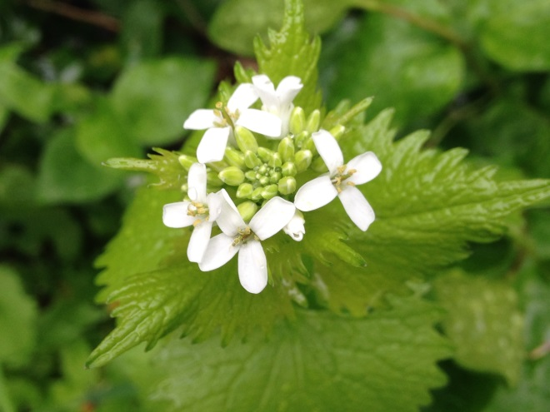
Yellow Archangel
Lamiastrum galeobdolon – Class B
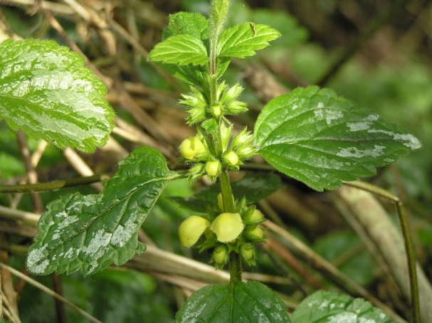
Control Required.

Herb-Robert
Geranium robertianum – Class B
Control Recommended.

Garlic Mustard
Alliaria petiolata – Class A
Eradication Required.
Please see our website for descriptions and control measures:

http://extension.wsu.edu/sanjuan/noxious/

