SIGNS OF DISEASE

A sign, as opposed to a symptom, is a manifestation of observable physical evidence of the actual causal agent of a disease. Signs are extremely useful in diagnosis and are more specific to the disease than are symptoms. A sign can be the presence of some structural part, residues or remains of a pathogen.

Signs of arthropod pests (insects, mites etc) and other animals can be the organism itself or a product from the organism. Signs can be in the form of insect frass, mite webbing, insect and mite eggs, slug and snail slime trails, cocoons, molt casts, etc. Quite often, signs are more obvious under moist conditions such as after rain, irrigation or early in the morning. For instance, Phytophthora infection of Madrone can be highlighted by wetting the surface of the damaged bark.

Signs of plant diseases are numerous and many can be overlooked while conducting a cursory examination of a plant problem. Close careful observation of the diseased plant is essential to an accurate diagnosis. Employment of direct aids such as a hand lens and a knife are indispensable while conducting an examination in the field.

Fungi

There are a large number of signs associated with fungal pathogens. Under most circumstances fungi can be identified by there hyphal structures, mycelium, fruiting bodies and/or spores. Hyphae are individual fungal filaments that make up the body (thallus) of a given fungus and are collectively called a mycelium. Mycelia can have different morphology, sizes and colors. Fruiting bodies are the structures of a fungus that produce sexual spores. The morphology of fruiting bodies is a primary factor in identifying different fungal genera and species. Most fungi also produce asexual spores. Asexual spores are essentially clones of the parent mycelium and in many species are called conidia (Greek for dust). Spores also come in a variety of shapes and sizes and are an important factor in identifying fungal pathogens. Many spores require higher magnification than a hand lens to identify the pathogen. The size, shape, color and growth characteristics of the thallus (body) of a fungus are major considerations for identification. The following structures are some of the more common signs of phytopathogenic fungi; many can be seen with the unaided eye or under low magnification

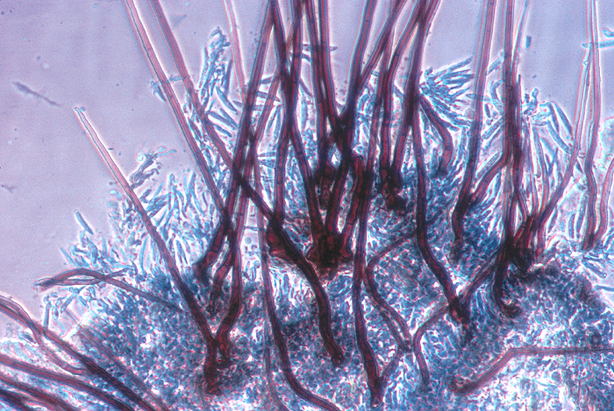
Acervulus: an open cup-like fruiting body containing conidia (asexual stage).
Acervulus with whiskerlike hyphae (setae) of an anthracnose fungus

Apothecium: an open cup-like fruiting body containing ascospores (sexual stage).

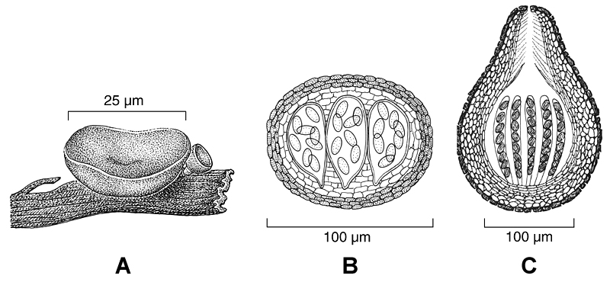
Perithecium: a round fruiting body with an opening at the top containing ascospores (sexual stage).

Cleistothecium: a spherical fruiting body without an opening containing ascospores (sexual stage).
A-Apothecium B-Cleistothecium C-Perithecium

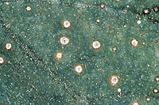
Pycnidium: a round fruiting body with an opening at the top containing Conidia (asexual stage).

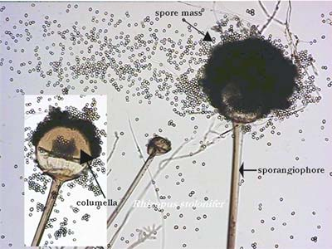
(For further clarification and characteristics see chapter on fungi)
Pycnidia of Septoria sp.
Rhizopus sp.

Mold: such as bread mold (Rhizopus sp.).

Mildew: a white mycelial growth on shoots, leaves, fruit and flowers

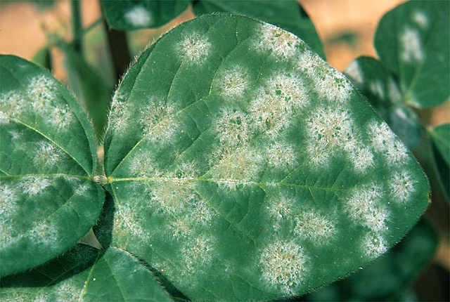
Mycelium: may be mat-like or resemble webs or threads

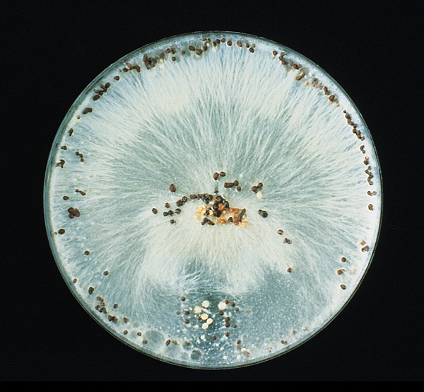
Sclerotium: hard dormant reproductive structures produced by some fungi that are durable enough to survive harsh conditions in soil or in plant debris for many years - Sclerotia have a hard brown to black outer layer with a white center and are about the size of a BB.
Powdery Mildew
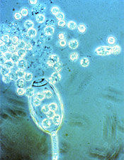
.
Sclerotium

Spores: spores are the reproductive structures of fungi. They are microscopic but may be seen when grouped together on the surface of mold, mildew or mycelium. Spores, in some cases, may also be seen when evacuating a fruiting body.
Fungal spores

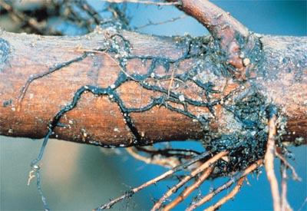
Rhizomorphs: Brown/black root-like aggregation of hyphae “shoe strings” that grow on root surface of plants. (E.g., Armillaria sp.).

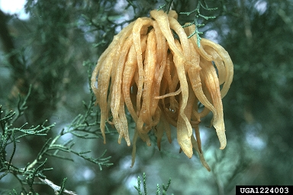
Rhizomorphs on roots

Spore horns (telial horns): jelly–like, spore-bearing structures of cedar-apple rust on red cedar (Gymnosporangium sp.).

Telial horns
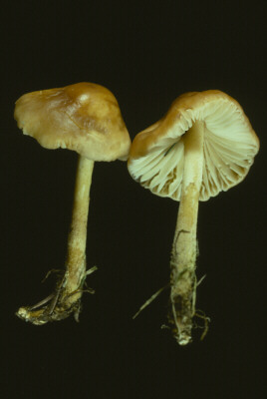
Mushrooms: mushrooms are fleshy spore-producing basidiocarps that produce bisidiospores on gills. There are many different types of basidiocarps, most of which are not phytopathogenic.

Bacteria

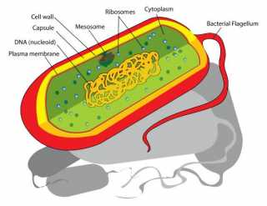
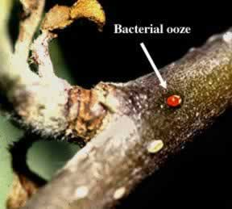
Bacteria are microscopic single-cell prokaryotic organisms which cannot be seen as single individuals without a compound microscope. However, under certain conditions, bacteria in mass can be seen with the naked eye. The following signs are common in certain bacterial infections and are considered diagnostic:
Typical bacilliform bacterium
Fire Blight of apple

Bacterial Ooze: an amber or cream color sticky liquid composed of bacterial cells oozing from natural openings, wounds or from infected tissue such as the borders of certain cankers. In bacterial wilt infections of cucurbits when a diseased stem is cut cross-wise and gently pulled apart, sticky strands will become evident between the two portions of the diseased tissue.

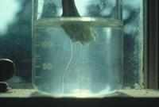
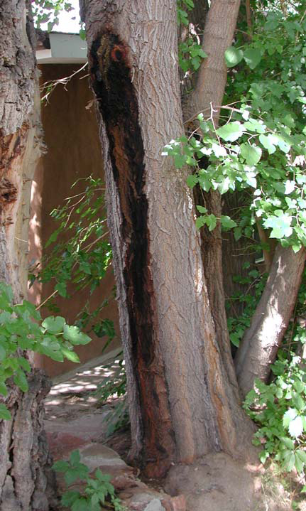
Bacterial Streaming: Another excellent sign of the presence of bacterial infection is streaming. Bacterial streaming can be seen, in some circumstances, under high magnification when infected tissue is placed on a slide with a drop of water and the sample is covered with a cover slip. Sometimes bacterial streaming, or clouding, can be seen with the naked eye when infected tissue is dipped in a glass of water. Bacterial ooze can be seen as it diffuses and sinks to the bottom of the glass.
Tomato Wilt bacterial streaming
Slim Flux on cherry

Slime Flux: Slime flux is associated with a bacterial disease of some trees and is known as Bacterial Wetwood. A bacteria-rich liquid seeps out of cracks or wounds and runs down the bark. This liquid can be composed of secondary bacteria, yeasts, fungi and plant cells. It will have a slimy texture and will often have a dark color and fetid odor.

Odor: Bacterial diseases such as soft rots will often give off a foul odor. This odor can be diagnostic in some bacterial infections. (E.g. Erwinia sp.)

Virus

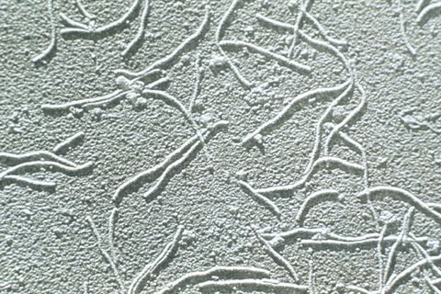
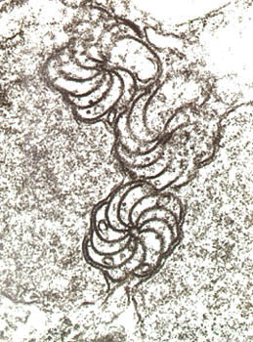
Viruses are extremely small and cannot be seen as individuals under a light microscope. Without proper laboratory equipment viral infections are diagnosed by symptoms on the diseased plant.
Potato Virus
Inclusion bodies

Inclusion Bodies: Cellular inclusions are produced by plant cells in reaction to infection by certain viruses. Inclusion bodies are crystalline virus aggregates that when stained can be seen by a high-power compound microscope. Inclusion bodies are considered signs.
Nematodes
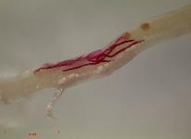
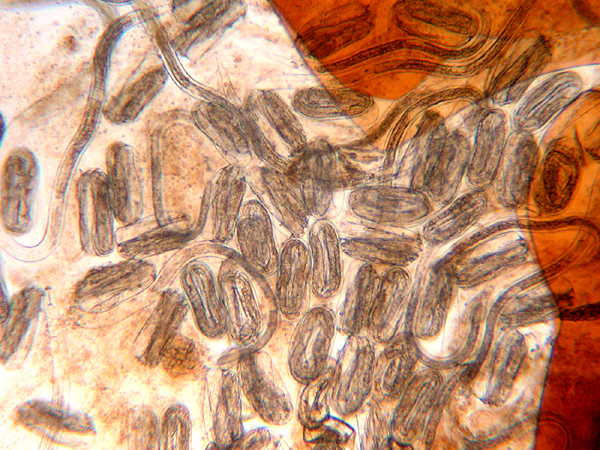
Nematodes are nonsegmented roundworms that are the most abundant multi-cellular animals on earth. Plant pathogenic nematodes have feeding structures (stylets) that are like sharp, hollow needles. This is diagnostic for plant pathogenic nematodes. Nematodes can be seen with a dissecting microscope but are better identified under higher magnification. Galls and other infested tissue induced by root-knot and cyst nematodes can often be teased apart revealing the pathogens. Concentrated populations of stem and bulb nematodes can result in nema wool which is a specific sign for the pathogen.
Endoparasitic nematode
Cyst nematode eggs and 2ed stage juveniles

Parasitic Angiosperms

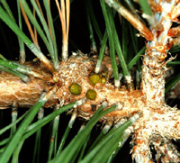
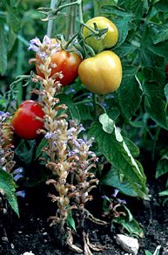
There are over 2500 species of higher plants that parasitize other plants. Parasitic higher plants do not have roots but produce, like some fungi, haustoria which invade the host plant and absorb water, nutrients and sometimes photosynthates.

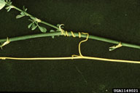
There are four major types of parasitic flowering angiosperems, broomrapes, witch weeds, dodders and mistletoes. The signs of these parasitic diseases are the pathogens themselves.
Dwarf mistletoe
Witchweed
Dodder

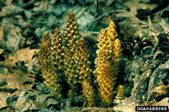

Jim Cooper, Master Gardner
WSU Extension, San Juan Co.
Copyright © August28, 2006
Squawroot (broomrape)

