Dear Future Sustainable Community Steward,

Welcome to the Sustainable Community Stewards program. We are a dedicated volunteer group that works on a variety of projects in Snohomish County including waste reduction, green cleaning, testing cars for oil leaks, tire pressure awareness, and more. We have over 30 active volunteers that give their time and energy to the above projects. Please carefully read the below information about the training and the program. On the next page you will find the application for our 2017 program.

Training
The 2017 training is on Wednesdays 6pm-9:15pm starting September 20th and ending November 10th. The training will mostly be held at the WSU Extension Offices in McCollum Park at 600 128th St SE, Everett, WA 98208, but at least two days will be held off-site at various locations around Puget Sound.

This course is fast paced, and a lot of information is covered in a short amount of time. With that in mind, it is requested that participants miss no more than two classes. There is a $35 materials fee for the course, and we offer a fee waiver with no questions asked. The waiver can be requested at the time you submit your application up to the night of the first class.

In the training we will have expert presenters speak on a variety of topics including climate change, sustainability, water quality, sustainable materials management, social marketing, and more. You will have weekly homework to further increase your knowledge on each topic, and a resource list if you’re interested in learning more about a particular topic.

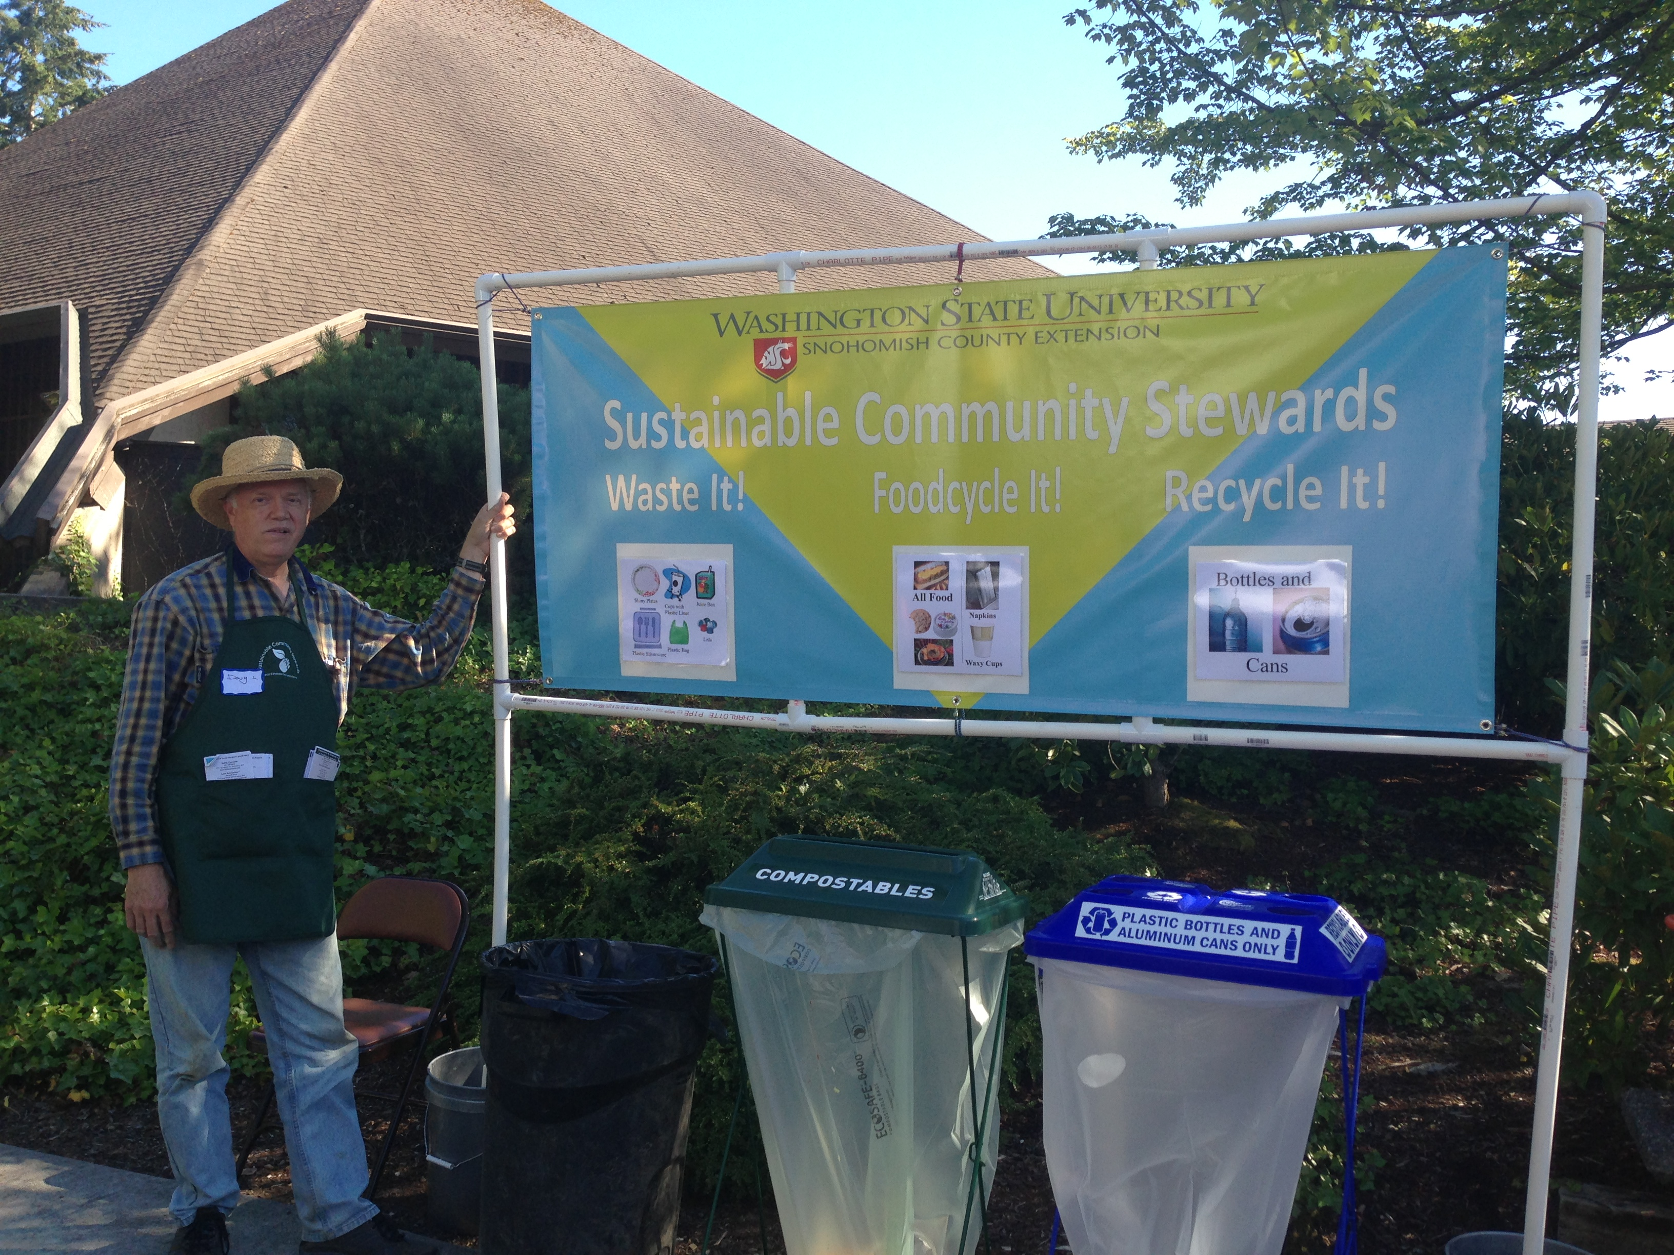
Volunteering
At the end of the training, you will be an official Sustainable Community Steward! Over the next year, you will receive notifications about a variety of volunteer opportunities that you are welcome to join to put forth your 34 hours. We attend multi-day festivals where we help community members sort their recycling and compostable items, we provide education on Household Hazardous Waste, we have information on how proper tire pressure can reduce climate change that we bring to outreach events, and more. Also, up to a quarter of your hours can go towards continuing education opportunities including SCS movie nights, educational potlucks, and more.

I hope with this information you feel informed, and prepared to join us for our 2017 class. Each volunteer brings individual talents to our group making us a diverse and fun group to be around. If you have any questions, or would like more information about the training, or the program, I’d be happy to speak with you via email, phone, or in person.

Cheers,

Stephanie Leeper
Sustainable Community Stewards Coordinator
425-357-6027 s.leeper@wsu.edu


Sustainable Community Stewards
2017 VOLUNTEER TRAINING APPLICATION

Return completed application by September 13th to:
Stephanie Leeper, Sustainable Community Stewards Program Coordinator
WSU Snohomish County Extension, 600-128th St SE, Everett, WA 98208
s.leeper@wsu.edu, Phone: 425-357-6027, Fax: 425-338-3994

Name: ___________________________________________________________________
Address: ______________________________ City: __________________ Zip: _________
Phones - Home:_________________________ Cell:____________________________
Best time/s to call: __________________________________________________________
Best Email address:_________________________________________________________
Emergency contact: _____________________________ Phone:______________________
Allergies/medical conditions: ___________________________________________________
__________________________________________________________________________

1. Why do you want to become a Sustainable Community Steward?

2. Please describe any environmentally related volunteer work you are/were involved in:

3. a) What environmental or sustainability issues concern you most?

b) What have you done to learn about the issues you listed above?

4. What educational experiences and work experiences do you bring to SCS?

5. Please describe any special interests or hobbies you have:

6. Please list your current volunteer commitments and/or past volunteer experiences:

7. Please list dates/times you will NOT be available for training (e.g. job, school, vacation, etc.).

__________________________________________________________________________

8. How did you hear about this training?
___ Newspaper advertisement (name of paper: ____________________________)
___ Newspaper article (name of paper:______________________________)
___ Newsletter (name: _____________________________________)
___ Radio station (name: _____________________________)
___ WSU Website
___ Notice emailed to you
___ Friend/neighbor
___ Sustainable Community Steward Volunteer
___ Professional acquaintance
___ Volunteer organization, service club, group (name: _____________________________)
___ Flyer or bookmark seen at _______________________________

Thanks!
Please return your application to Stephanie Leeper s.leeper@wsu.edu or 600-128th St SE, Everett, WA 98208

