
C0932

LEVEL 1 (Recommended for beginning 4-H members)

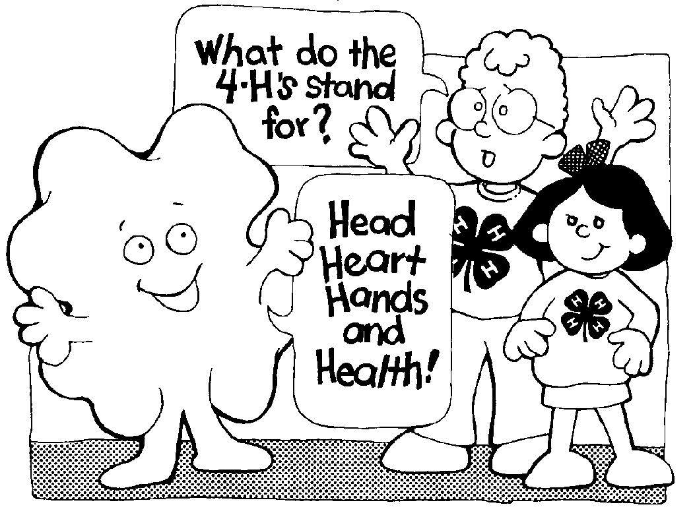

Name: |  |  | Year:

Address:
Birthday: |  | Grade in School:
Age: | Number of years in 4-H:

Club Name:

INSTRUCTIONS

- Use this record book and your Level 1 4-H Permanent Record for all the things you do in 4-H this year.
- Use separate "Project Plan", "Project Diary", and "This is what I did in my 4-H project" forms for each of your projects.
- There may be add sheets for projects with special planning or recording needs (breeding records, milk records, garden plan).
- Use your record to look back at the progress you have made during the year. This will be helpful when you make plans for next year.
- When you complete your 4-H program for this year, write your 4-H story.
- You will want to keep only the most important materials in the memories part of your record. You may want to keep a scrap- book of ribbons, certificates, programs, and other materials.
- The record book is your personal work. It should be kept current as the year progresses. Handwriting or typing should be your own.
- You may want to organize your records with tabs in a binder.
A suggested order for doing this is:
• Introduction
• My 4-H Planning Calendar
• Projects (separate tabs for each project)
• Permanent Record
• My 4-H Story
• My 4-H Memories
• Comment Page

9. Obtain the required signatures.



MY 4-H PLANNING CALENDAR
Check the box for each event you attended.
October | Date | Location | Event/Activity | Time | Attend
October | Add rows by putting your mouse just outside the border of the row above where you want a new row and hit enter

November | Date | Location | Event/Activity | Time | Attend
November | Add rows by putting your mouse just outside the border of the row above where you want a new row and hit enter

December | Date | Location | Event/Activity | Time | Attend
December | Add rows by putting your mouse just outside the border of the row above where you want a new row and hit enter

January | Date | Location | Event/Activity | Time | Attend
January | Add rows by putting your mouse just outside the border of the row above where you want a new row and hit enter

February | Date | Location | Event/Activity | Time | Attend
February | Add rows by putting your mouse just outside the border of the row above where you want a new row and hit enter

March | Date | Location | Event/Activity | Time | Attend
March | Add rows by putting your mouse just outside the border of the row above where you want a new row and hit enter

April | Date | Location | Event/Activity | Time | Attend
April | Add rows by putting your mouse just outside the border of the row above where you want a new row and hit enter

May | Date | Location | Event/Activity | Time | Attend
May | Add rows by putting your mouse just outside the border of the row above where you want a new row and hit enter

June | Date | Location | Event/Activity | Time | Attend
June | Add rows by putting your mouse just outside the border of the row above where you want a new row and hit enter

July | Date | Location | Event/Activity | Time | Attend
July | Add rows by putting your mouse just outside the border of the row above where you want a new row and hit enter

August | Date | Location | Event/Activity | Time | Attend
August | Add rows by putting your mouse just outside the border of the row above where you want a new row and hit enter

September | Date | Location | Event/Activity | Time | Attend
September | Add rows by putting your mouse just outside the border of the row above where you want a new row and hit enter

PROJECT PLANS

My 4-H project is: Tell the title of your Project (examples: Cavy, Dog Care, Sewing for Fun, Beginning Horsemanship). In animal projects, tell how many animals you have in this project. You can include their names. Replace this text with your information.

I chose this project because: Tell why you are involved in this project. Is your family involved? Do you have a special reason for being interested in this project? Replace this text with your information.

Some of the things I want to do or learn in my 4-H project this year are:
What particular things do you want to learn about your project? In what club and project activities do you want to participate? What do you want to do with your project?

Each goal should be specific, measurable, and appropriate for your age, experience, and ability level.

Here are some examples:

I want to learn the parts of the (horse, cat, sewing machine) and be able to name them when quizzed by my leader.

I want to learn how to Fit and Show and try it at the an open show and at the fair.

I want to participate in Quiz Bowl at the fair.

Replace this all this text with your learning goals.

Member:
Parent/Guardian:
Leader:
PROJECT DIARY

Date | What did you do or make? | How much?  How many? | Cost | Income/  Value
Example: October | Fed animal daily. | 120#grain | $10.80 | NA
Oct 2 | Had horse shod. | 4 shoes | $35.00 | NA

Totals
Add rows by putting your mouse just outside the border of the row above where you want a new row and hit enter

This is what I did in my 4-H project this year:
Tell the highlights of your 4-H year relating to your project. Make sure these highlights relate back to the goals you set in your project plans. Replace this text with the review of your project year.

Pictures of my project


Replace the clover with a picture of your own. Replace this text with a caption including time, date, place.

PROJECT RELATED MATERIALS

  Replace the clover with a picture of your own. Replace this text with a caption including time, date, place.  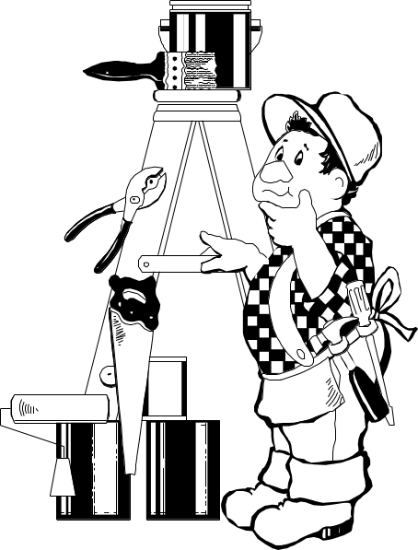 | Replace the clover with a picture of your own. Replace this text with a caption including time, date, place.
Replace the clover with a picture of your own. Replace this text with a caption including time, date, place.

If the table cells are not the right direction for your photos, go to TABLE and click on “split” or “merge” cells. You can delete this row by right-clicking and hit DELETE ROWS. You can add rows by putting your mouse just outside the green border of the row above where you want a new row and hit return.
MY 4-H STORY

Some things about myself and my family are. . .

I joined 4-H because. . .

Some of the things my club and project group did this year were. . .

When you tell this part of the story, tell the activities you were involved in. Include project activities, fun activities, community service, fair, etc. Make sure you tell us how the activities helped you meet the goals you listed in your project plans. Replace this text with your own words.

MY 4-H STORY (continued)

My favorite parts of 4-H this year were . . .

Some things I would like to do better, improve upon, or do more of next year are . . . Replace this text by telling us what didn’t go the way you expected? What you want to improve? What activities or goals do you want to include next year?

MY 4-H MEMORIES
Paste pictures of you, your club, drawings, newspaper clippings, letters,
awards, or anything related to you and your club or 4-H project.

Replace the clover with a picture of your own. Replace this text with a caption including time, date, place. | Replace the clover with a picture of your own. Replace this text with a caption including time, date, place.
Replace the clover with a picture of your own. Replace this text with a caption including time, date, place. | Replace the clover with a picture of your own. Replace this text with a caption including time, date, place.
If the table cells are not the right direction for your photos, go to TABLE and click on “split” or “merge” cells. You can delete this row by right-clicking and hit DELETE ROWS. You can add rows by putting your mouse just outside the green border of the row above where you want a new row and hit return.

MY 4-H MEMORIES

Replace the clover with a picture of your own. Replace this text with a caption including time, date, place. | Replace the clover with a picture of your own. Replace this text with a caption including time, date, place.
Replace the clover with a picture of your own. Replace this text with a caption including time, date, place. | Replace the clover with a picture of your own. Replace this text with a caption including time, date, place.
If the table cells are not the right direction for your photos, go to TABLE and click on “split” or “merge” cells. You can delete this row by right-clicking and hit DELETE ROWS. You can add rows by putting your mouse just outside the green border of the row above where you want a new row and hit return.

COMMENT PAGE
To be filled out by leaders, record book judges, and others at the end of the 4-H year.

Leaders and parents may replace this text with information about the child, the 4-H Club, the project(s), or about the record book completing process.

I have reviewed this record book and believe it to be correct.
Member _____________________________________________ Date ________
Parent/Guardian _______________________________________ Date ________
Leader _______________________________________________ Date ________
Leader ______________________________________________ Date ________

the 4-h pledge
I pledge
my head to clearer thinking;
my heart to greater loyalty;
my hands to larger service;
and my health to better living;
for my club,
my community,
my country,
and my world.



Issued by Washington State University Cooperative Extension and the U.S. Department of Agriculture in furtherance of the Acts of May 8 and June 30, 1914. Cooperative Extension programs and policies are consistent with federal and state laws and regulations on nondiscrimination regarding race, color, gender, national origin, religion, age, disability, and sexual orientation. Evidence of noncompliance may be reported through your local Cooperative Extension office. Published September 1989. Revised for Web May 2001. Subject Code 839. A. C0932

