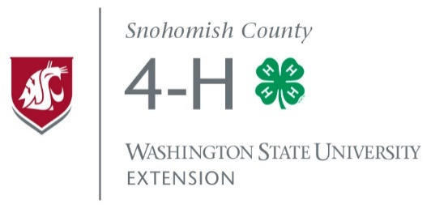
4-H MULTI-COUNTY
OFFICER TRAINING

Youth Officer Training is open to any 4-H youth who was
elected to office or is interested in becoming an officer.

WHERE: Evergreen State Fairgrounds – 4-H Building #501
WHEN: November 12, 2016 10:00a.m – 3:00p.m.
What to Bring: A lunch and dress for the weather. (Depending on the weather, we may have some outdoor exercises.)
Workshops for youth on leadership, parliamentary procedure, how to be a president, vice president, secretary, treasurer and more. Hands-on practice in a mock meeting. Parents/leaders workshop on how to support youth leaders will also be offered. Open to any 4-H youth who was elected to office or is interested in becoming an officer.
To register or if you have questions, please contact Sylvia Hales, the
4-H Secretary at sylvia.hales@wsu.edu or call 425-357-6044.

WSU Extension programs are available to all without discrimination. Evidence of noncompliance may be reported through your local Extension office. Persons with disabilities who require alternative means for communication or program information or reasonable accommodations need to contact Jana Ferris at WSU Extension, 600 128th ST SE, Everett, WA 98208, at least two weeks prior to the event.

