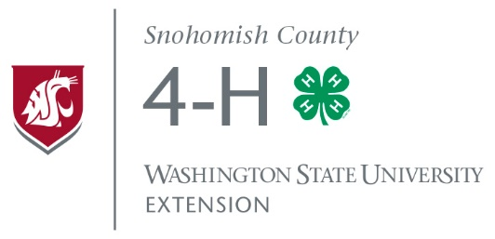

Snohomish County
Independent 4-H Member Comprehensive Plan

Name |  | Phone
Address |  | State |  | Zip
Name of Mentor (must be willing to have a criminal background check) |  |  | Mentor Phone Number
Mentor email address Mentor Signature/Date | Mentor Signature/Date
Extension Representative (ER) Signature |  |  |  | Date

Project #1
Project Goals (Things I want to accomplish this year, complete at least 3)

1.

2.

3.

4.

Project #2
Project Goals (Things I want to accomplish this year, complete at least 3)

1.

2.

3.

4.

Citizenship and Community Service Goals

(Things you can do with/for other individuals and groups in the community, county and beyond)

1.

2.

3.

4.

Leadership Goals
(Things you can do to improve your leadership and to share what you learn with others. Consider attending State Teen Conference [June] and Know Your Government [February].)

1.

2.

3.

4.

I will participate in the following events (*Participate in at least 2 of these events)

Project-related clinic/workshop (attend at least 2)
Fall Explore 4-H (October 4, 2017)*
WSU Livestock Advisors Country Living Expo (January 27, 2018)*
NWMRC Train Show (Feb. 23-25, 2018)*
Snohomish County 4-H Equine Tack Sale (March 2-4, 2018)*
Dog Caper (May 11-13, 2018)*
Fair (August 23-September 3, 2018)*
Other (Please indicate)

Submit a progress report of 4-H project activities two times during the program year
to the WSU Snohomish County Office. The report can be a 100-300 word project summary, presentation of project activities, or alternative method upon agreement of both member and ER.

Date to submit report
(January)

Date report submitted

Date to submit report
(May)

Date report submitted

Submit a final report of 4-H project activities (at the end of the program year) to the WSU Snohomish County Extension Office. Report is to be a 200-300 word project and service activity summary, presentation, or other method agreed by both member and ER.

Date to submit report (September)

Date report submitted

Prepare and deliver a presentation (10 minutes maximum) to 4-H Council (October meeting – 2nd Wednesday) or the program meeting for one of your projects during October, November, or December. This presentation should provide a review of the program year activities.

Year End Completion Statement

I certify that (4-H member) has successfully completed the minimum goals and community activities in this plan.

Extension Representative Signature Date

Note: This Individual Members Comprehensive Plan is to be initially planned and submitted within two weeks of enrollment with copies to the Advisor/Mentor and the WSU Snohomish County Extension Office. A third copy will be kept by the member. The member’s copy will be turned in at the end of the program year as part of the final report.

