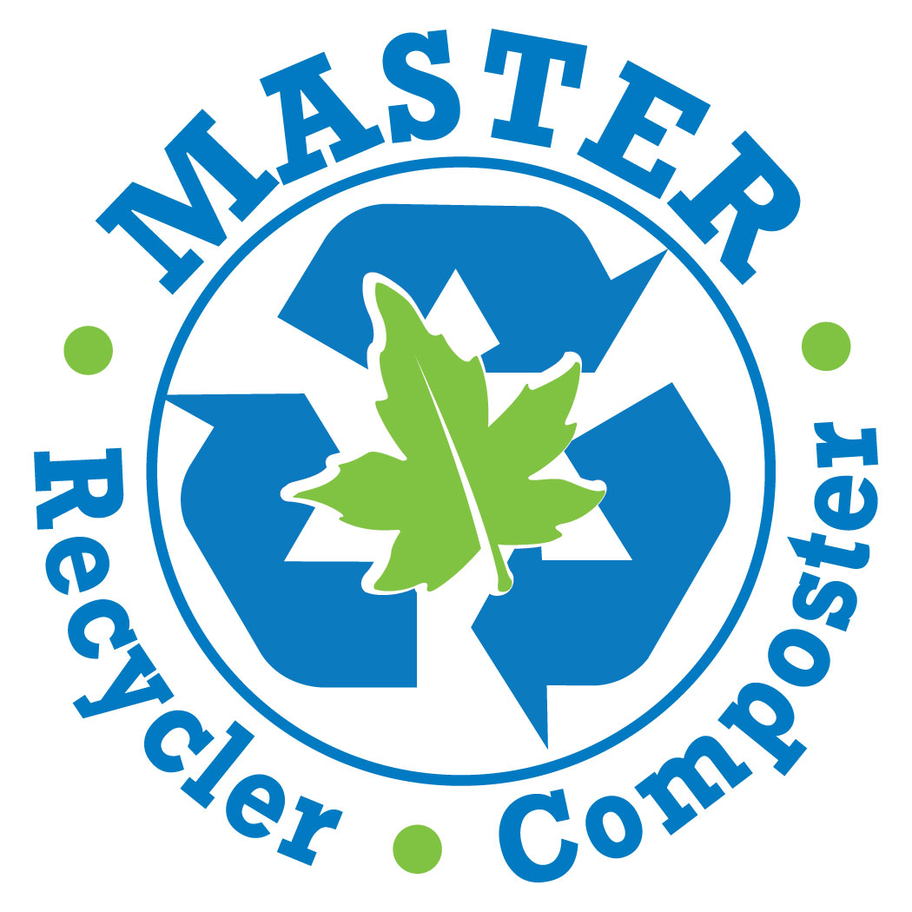

2017 Master Recycler Composter Volunteer Application

Thank you for your interest in becoming a Thurston County Master Recycler Composter volunteer. Please fill out the application completely and legibly. Selection for the Master Recycler Composter volunteer program is based on information you include in this application.

Training to become a Master Recycler Composter occurs every other year in the fall. Tuesday training classes are from 6p.m. to 8:30p.m.on September 19th, 26th and October 3rd, 10th, 17th, 24th plus field experiences from 9a.m. to 1p.m. on Saturday, September 30th and October 14th.

Return this application by September 5th to assure consideration for the next training class. Space is limited so don’t delay, apply today!

Once you complete the application, please save and email/mail the form back to Cori Carlton, Thurston County Master Recycler Composter Program Manager at:

Email: carltoc@co.thurston.wa.us

Or

Print and mail it to- WSU Thurston County Extension
Attn: Cori Carlton
5033 Harrison Ave. NW
Olympia, WA 98502

Acceptance letters will be issued once applications have been reviewed, processed and background checks are complete.

Please retain a copy for your records.

If you have any questions - please call our office at 360-867-2162.

A $25 training fee will be collected at the first class. This fee covers the remaining training supply and field trip costs that are not subsidized by Thurston County Solid Waste Department and the Master Gardener Foundation of Thurston County.

Send no payment with this application!

Master Recycler Composter of Thurston County Application
PLEASE PRINT or TYPE

PART A:
**Note that to become a Master Recycler Composter volunteer you must be 18 years of age or older. Are you 18 years of age or older? Yes_____ No_____

Contact Information

Name:
(First) (Middle) (Last) (Maiden)

Name you prefer to use (nickname, etc.)___________________________________
What name do you want listed on your name badge? _______________________________

Mailing
Address:
(Street) (City) (Zip)

Phone:
Day: ( ) _____________________ Best Time to Call: _______________
Eve: ( ) ______________________ Best Time to Call: _______________
Cell: ( ) ________________________ Best Time to Call: _______________

Do you have access to a computer with internet and have an email address? Yes____ No_____
If no, are you willing to get an email address and find access to a computer? ______________

Email Address (required):
(Please type or print very clearly)

Emergency contact (other than your own home contact information):
Name: __________________________________Relation:__________________________
Phone: ( ) ___________________________

Participation in Training Classes
Can you attend the following scheduled training classes?
- Tuesday training classes from 6p.m. to 8:30p.m.on
  - September 19th
  - September 26th
  - October 3rd
  - October 10th
  - October 17th
  - October 24th
- Saturday, September 30th from 9a.m. to 1p.m.
- Saturday, October 14th from 9a.m to 1p.m.

Every class is important and attendance is expected. You will have to make up any classes you miss. Do you have any concerns with this? ___________ If so, please comment:
__________________________________________________________________________
___________________________________________________________________________

Please advise us of any special accommodations needed for you to participate in the upcoming training class: ________________________________________________________________________________________

Thurston County Master Recycler Composter volunteers are asked to serve a minimum of 25 hours/year (20 hours of service and 5 hours of continuing education credits). The purpose of 5 hours of continuing education credits (CE) is to stay current with industry and science-based information. Recycling and composting practices can change frequently. As Thurston County Master Recycler Composters we try to be most accurate when talking to the public. There will be opportunities for CE through workshops, publications, webinars, e-newsletters etc.

Do you have the time to commit to a minimum of 25 hours of volunteer service during your internship? Yes_____ No_____ (September 19, 2017—September 30, 2018)

I would be most available:
Weekdays______ Evenings_____ Weekends_____ Summers only_____ Other_______

Service Area: Check the geographical area or areas in which you would be willing to volunteer.
____Lacey ____Tumwater ____Olympia _____Rochester/Littlerock ____Tenino

____Yelm _____ No Preference

Training/education completed:
 High school
 Technical/trade school (major studies)___________________________________________________
 2-year community college (major studies)_________________________________________________
 4-year college (major studies)___________________________________________________________
- Horticulture degrees, training, or certifications (specify)______________________________________
___________________________________________________________________________________
___________________________________________________________________________________

Occupation_____________________________________Position_____________________________
Full time_____ Part time_____ Shift_____ Seasonal_____ Student_____ Retired_____
If not employed/student, are you actively seeking employment? Yes_____ No_____

Please describe your composting and recycling experience: (any personal, volunteer, or work experience)

List any volunteer experience in the community:

In your volunteer role, with whom do you prefer to work with?
 Youth  Adults  Both

If you prefer to work directly with youth, what grade level(s) do you prefer?
 Primary (Grades K-2)
 Junior (Grades 3-5)
 Intermediate (Grades 6-8)
 High school (Grades 9-12).

Which of the following topics do you have interest or experience in and be willing to learn/share with others while volunteering for our program: (please check all that apply)

 Composting yard waste @ home |  Composting food waste @ home |  Pros/cons of compost bin styles
 Worm composting |  Wildlife problems in compost |  Organization/business composting
 Curbside home recycling |  Curbside home organics/yard waste collection |  Organization/business recycling
 Recycling or composting @ schools |  Wasting Less Food |  Upcycling/Repurposing
 Landfills |  Packaging |  Other-please describe
Other skills, interests or experience you are willing to offer while volunteering for our program: (please check all that apply)
The skills you are willing to share with us is just as important as prior gardening experience. We need people with all types of experience to help further our program goals.

 Writing articles |  Drawing/illustrating |  Research/data collection
 Website management |  Publicity/marketing |  Public speaking/teaching
 Social media |  Artwork/displays |  Grant writing
 Photography |  Proofreading |  Fundraising
 Event planning |  Video production |  Financial management
 Office/clerical skills |  Volunteer management |  Financial investing
 Skilled Labor (i.e. electrical, plumbing, carpentry, mechanics, painting, welding etc.) |  Computer skills-list software |  Other-please describe

If needed, please provide specific information on the above checked categories:

Why do you wish to become a Master Recycler Composter volunteer?

Are there any volunteer activities in which you are unwilling or unable to participate (public speaking, attending meetings, office work including answering phones and emails, working one-on-one with community clients, physical composting work in the demonstration gardens, etc.)?  No  Yes
If yes, please list: (please be honest, if you write something down it will not deter you from being accepted into the program.) ______________________________________________________________________________________________________________________________________________________________________________________________________________________________________________________________________________

Describe your comfort with public outreach
How comfortable are you with: (1 being least comfortable, 5 being most comfortable or N/A=never done)
1) Starting a conversation with a stranger 1 2 3 4 5 N/A
2) Staffing an information booth at a community event 1 2 3 4 5 N/A
3) Getting someone to participate in an activity 1 2 3 4 5 N/A
4) Presenting a topic to others 1 2 3 4 5 N/A

If you are able to speak, read, or write a language(s) other than English, please list: (including American Sign Language)

Any other information about your skills and abilities you would like us to know?

How did you learn about the Master Recycler Composter program?
____________________________________________________________________________

Have you used Master Recycler Composter services before? ____Yes ____No
Volunteer Service Agreement
Thurston County provides workers’ compensation coverage for volunteers and will defend a volunteer against any claim or law suit arising out of the performance of the services rendered under this agreement, per RCW 4.96, provided the volunteer has acted within the scope of the duties defined in this agreement. Volunteers shall report all volunteer service hours to the reporting office, department or supervisor for purposes of reporting and accounting to the Department of Labor and Industries.
If accepted into the Master Recycler Composter Program, I agree to:
- Represent Thurston County with dignity and pride.
- Respect all persons with whom they interact as a Thurston County Master Recycler Composter (fellow volunteers, county personnel, and general public).
- Conduct themselves in a courteous, respectful manner refraining from profanity, harassment, disruptive behavior, or abuse of any kind.
- To complete the “Put the Child First” child protection training and be a positive role model when working with youth.
- Respect and follow county and program policies and guidelines.
- Comply with nondiscrimination laws.
- Refrain from using alcohol and other drugs in an illegal or inappropriate manner.
- Participate as team members within the Master Recycler Composter program.
Master Recycler Composters are representatives of Thurston County and should dress in appropriate and professional manner. This includes always wearing one’s name badge when serving as a Thurston County volunteer. Clothes should be suitable for the activity or location. Office casual is appropriate for indoor speaking engagements or promotions. Work clothes are appropriate for composting and recycling service.

I consent to Thurston County WSU Extension performing a background check into my history in accordance with RCW 43.43.830 through RCW 43.43.845, and waive any right to privacy I may have in such information for the limited purpose of the County considering if for determining my suitability as a volunteer.
I agree ______ I disagree______

Signature__________________________________________ Date ___________________
Washington State Patrol Criminal History Reports: To meet state regulations, all participants are required to complete a Washington State Patrol Criminal History Report before volunteering as Master Recycler Composter volunteers.

Fill out Part A: Application and Part B: Criminal History Disclosure Form below and email OR mail both to:

Email: Cori Carlton at carltoc@co.thurston.wa.us

Mail:
WSU Thurston County Extension
Attn: Cori Carlton
5033 Harrison Ave. NW
Olympia, WA 98502

PART B: Criminal History Disclosure Form

Background Disclosure – this information is required of ALL potential volunteers in Thurston County & WSU Extension Programs and is kept confidential and in a locked cabinet in your local extension office. Please note that a background check may be conducted on all potential volunteers.

Name:
(First) (Middle) (Last) (Maiden)

Former Name(s) Legal or Preferred Name(s)

Date of Birth (MM/DD/YY) Driver’s License Number/State

Answer YES or NO to each listed item. If the answer is YES to any item, please explain in the area provided, indicating the charge or finding, the date, and the court(s) involved.

Have you ever been convicted of a misdemeanor or a felony?
- Yes | - No | If yes, please give date, nature, and disposition of offense.

Have you ever been convicted of a crime(s) against children or other persons?
- Yes | - No | If yes, please give date, nature, and disposition of offense.

Have you ever been convicted of a crime(s) relating to financial exploitation if the victim was a vulnerable adult?
- Yes | - No | If yes, please give date, nature, and disposition of offense.

Have you ever been convicted of a crime(s) related to drugs?
- Yes | - No | If yes, please give date, nature, and disposition of offense.

Have you ever been found in any dependency action under RCW 13.34.040 to have sexually assaulted or exploited any minor or to have physically abused any minor?
- Yes | - No | If yes, please give date, nature, and disposition of offense.

Have you ever been found by a court in a domestic relations proceeding under Title 26 RCW to have sexually abused or exploited any minor or to have physically abused any minor?
- Yes | - No | If yes, please give date, nature, and disposition of offense.

Have you ever been found in any disciplinary board final decision to have sexually or physically abused or exploited any minor or developmentally disabled person or to have abused or financially exploited any vulnerable adult?
- Yes | - No | If yes, please give date, nature, and disposition of offense.

Have you ever been found by a court in a protection proceeding under chapter 74.34 RCW, to have abused or financially exploited a vulnerable adult?
- Yes | - No | If yes, please give date, nature, and disposition of offense.

Please note: A criminal record will be considered as it relates to specifics of the volunteer position for which you are applying. A criminal record may prevent an individual from volunteering, depending on the nature of the offense.

State Law Requirements:
The Washington State Child and Adult Abuse Information Law (RCW 43.43.830-.845) requires employers ask applicants to disclose specific information about any convictions for crimes against persons, crimes relating to financial exploitation, and findings in related actions and proceedings. This conviction information must be disclosed before an applicant can be considered for employment in any position which may involve unsupervised access to children, developmentally disabled persons, or vulnerable adults as defined by the law.

I, _______________________, hereby authorize Washington State University Thurston County Extension to investigate my background for purposes of evaluating whether I am qualified for a position with duties involving unsupervised access to children under the age of sixteen and vulnerable adults as defined in the Revised Code of Washington 43.43.840-43.43.845. I understand that Washington State University Thurston County Extension will utilize an outside firm(s) to assist them in checking such information, and I specifically authorize such an investigation by information services and outside entities of the company’s choice. I also understand that I may not withhold my permission and that in such case, no investigation will be done, and my application will not be processed further.

Signature: ____________________________________________ Date: __________________

Certification of Criminal History Outside of the State of Washington

I certify, under penalty of perjury that I have not been convicted of any of the above listed crimes or had findings against me concerning that above listed proceedings outside of the State of Washington.

Agree_________

Disagree__________

Personal Information (Please complete all requested fields)

Full Legal Name (Last, First, Middle): _________________________________________________________________
Alias/Maiden Names: ________________________________________________
Date of Birth: _____________________
Email Address: _________________________________________________________________
Telephone Number: ____________________________________________________________

I understand that a criminal background check will be completed prior to final consideration of my application to volunteer. I understand that misrepresentation or omission of required information is just cause for non-appointment as a volunteer with Thurston County and Washington State University Extension. I understand that I serve at the pleasure of Thurston County and Washington State University Extension and agree to abide by the policies of Thurston County, Washington State University Extension and individual program areas and to fulfill the volunteer responsibilities to the best of my ability.

Signature: Date:

