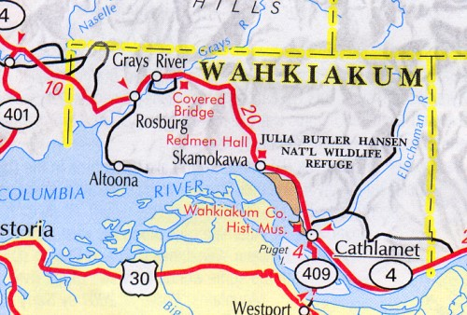

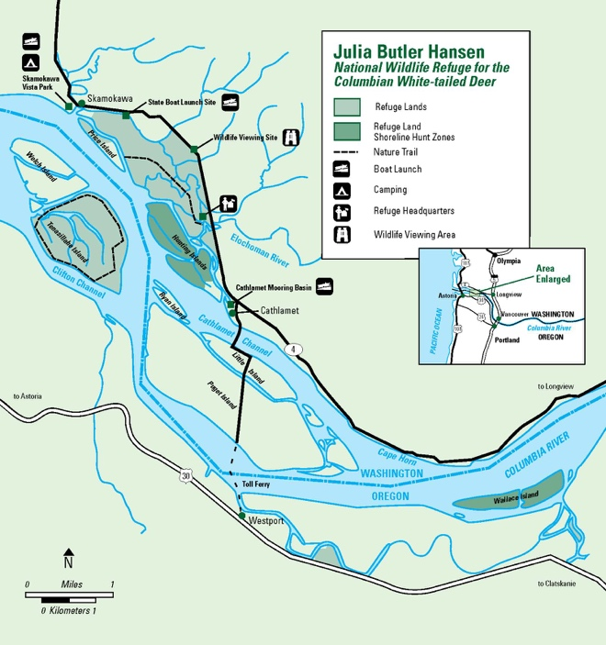

Great White Tail Run
P.O. Box 43
Rosburg, WA 98643

33rd Annual
Great White Tail Run

May 20th, 2017
Skamokawa, WA

Sponsored by
Wahkiakum 4-H

DATE: Saturday, May 20th, 2017
TIME: Registration begins at 8:30am
Run at 10am

COURSE: 10K, 5K, 2 mile through Julia Butler Hansen National Refuge in Skamokawa, Washington

AWARDS: Recognition given for overall male and female winners in each event, ribbons for top three finishers in each age division.

REGISTRATION AT
SKAMOKAWA VISTA PARK

FEES: Pre-run $10 w/out shirt, $20 with shirt. Run day $12 w/out shirt, $25 with shirt. Add $1 if you are bringing your dog and want to compete for award in this division.
Family or youth group discount: First 2 entries of immediate family/group regular price, each additional entry is $3 off regular price.

OFFICIAL DOG RULES: Socialized dogs only. Dogs should be at least 6 months old with current vaccinations. Dogs must be on leash at all times and stay on designated course. Female dogs in season are not permitted.

PRE REGISTRATION DEADLINE:
To guarantee a shirt, have your entries in by MAY 5. Mail in entries need to be received by MAY 17.

For further information, call:
360-465-2275 or 360-795-3278

The Washington State University 4-H Youth Development Program is a county-based program with educational support from the University. Youth age kindergarten through 19 years are involved in learning life skills through working in project areas with adult volunteer leaders. 4-H encourages responsibility, decision-making, record keeping, and team work. This event is a fundraiser for the Wahkiakum County based 4-H program and all proceeds will be used to benefit the county program.

The Julia Butler Hansen National Wildlife Refuge, in addition to protecting endangered deer is also a wintering area for waterfowl on the Pacific flyway.

Skamokawa Vista Park has showers, playgrounds, yurts, overnight campsites & RV accommodations. For reservations call 360-795-8605.

REGISTRATION FORM
Great White Tail Run
Wavier: In consideration of acceptance of my entry, on behalf of myself, my heirs, executors, administrators and assigns, I waive and release any and all right to claims of damages which I may have against the Julia Butler Hansen National Wildlife Refuge, the Skamokawa Vista Park, Wahkiakum County, Wahkiakum 4-H Council, WSU as well as any other person connected with the Run, their heirs, executors, administrators, successors, and assigns for any and all injuries which I may suffer while taking part in this event or as a result thereof. I attest and verify that I have full knowledge of the risks involved in this event and that I am physically fit and sufficiently trained to participate.
Signature_________________________
Parent/Guardian if under 18
Date_____________________________

Name____________________________
Address__________________________
_________________________________
Age_______Male_______Female_____
10K____5K_____2 Mile____w/dog____
Shirt Size: Adult S___M___L___XL___
Youth S____M_____L____ No Shirt____

Send entry to: GWTR, P.O. Box 43, Rosburg, WA 98643
Please make check payable to GWTR

