
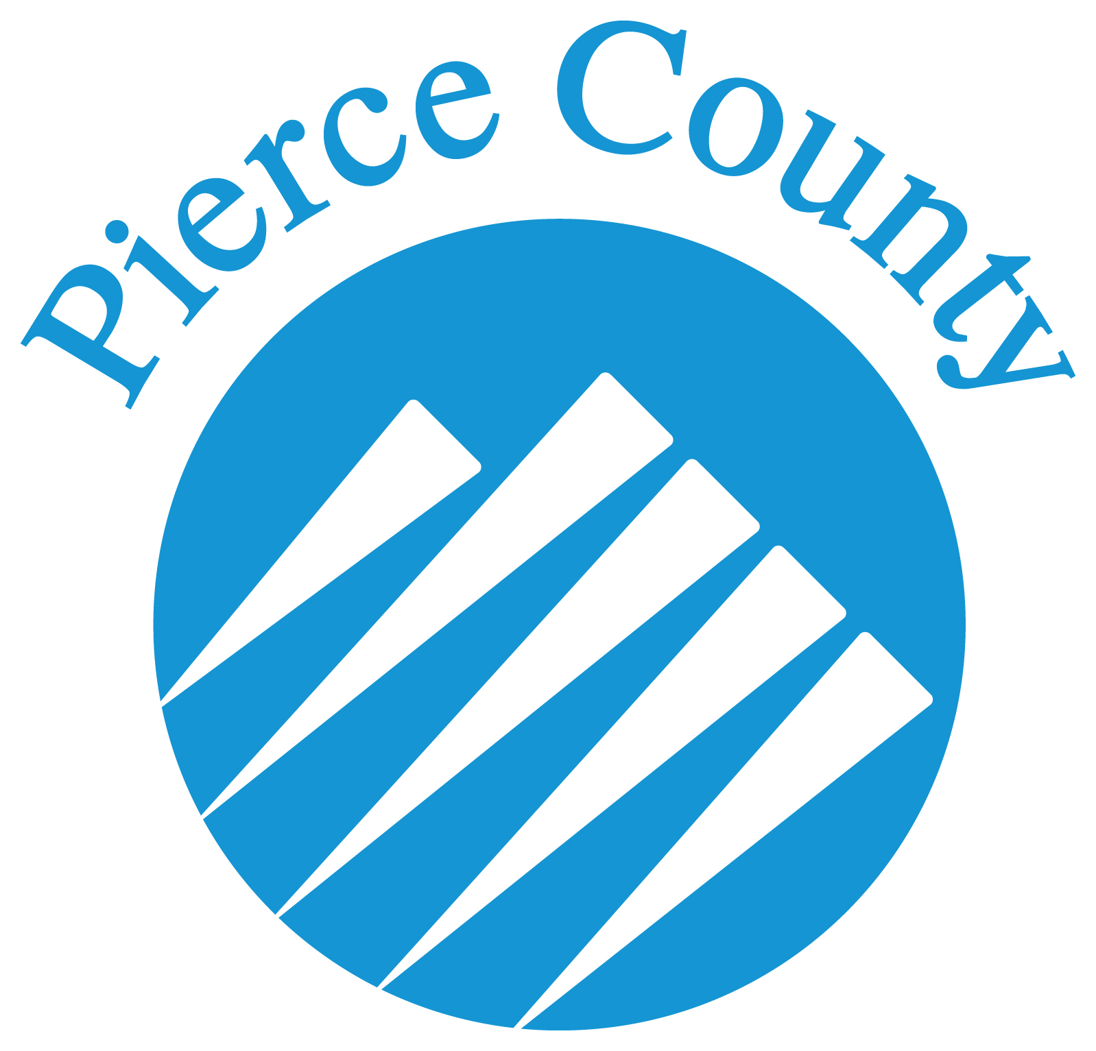
Lesson or project
Description (DO):

Life skills to be gained: | Example: decision making, communication, teamwork
FRAME lesson/content and life skill. What will you say? and/or
What ACTIVITY will you plan?
Question/s for WHAT (Share)
Purpose: What did you do? What were your observations, reactions?

Question/s for SO WHAT (Process and Generalize)
Purpose: What did you learn? Relate the experience to the life skill or subject matter. Connect experience to real world examples.

Question/s for NOW WHAT (Apply)
Purpose: What will you do with the learning? Where will they use the skills learned in another part of their lives?

ACTIVITY (optional) to facilitate reflection questions.

ACTIVITY ideas for framing and reflection:  Purpose: Provides different learning methods for various multiple intellligences and learning styles. | snow ball fight, dice roll, beach ball, playing cards, play dough creation, talking knot/circle, stuffed animals, pair/group sharing, weather forecast, Kodak moment, word whip, emotion face cards, continuum 1-10, slide show, good gossip, text a friend, Hollywood scene, growth circle, journaling, group poem

Experiential Learning Lesson Planning Worksheet
Created by Christina Murray, WSU Pierce County Extension

Created by Christina Murray, WSU Pierce County Extension
Created by Christina Murray, WSU Pierce County Extension

