

**Wahkiakum County**

**4-H RECORD BOOK**

**Year: _____________**



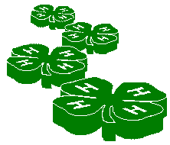

Head Heart



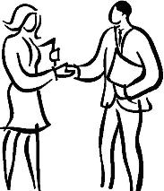

Hands Health

**Name: ________________________________ Years in 4-H: ________ Age: __________**

**Date of Birth: ________________ Grade in School: _________**

**\*4-H Age Division: Clover Bud_____ Junior _____Intermediate ____Senior_______**

**Address: ________________________________________________________________**

***City State Zip***

**4-H Club: _______________________________________________________________**

***IMPORTANT: Save this book for future reference when you are in high school and need scholarship(s) or job reference materials. Or to look back on fond memories of your 4-H years. We recommend getting a 3 ring binder and snapping them in at the end of each 4-H year!***

**\*NEW: Clover Bud – Age 5 to 7 years old Junior – 8 to 10 years old**

**Intermediate – Age 11 to 13 years old Senior – 14 to less than 19 years old**

# **INSTRUCTIONS**

1. Use this record book for all the things you do this 4-H year.

2. Use separate “Project Plan,” “Project Journal,” and “What I Did in My 4-H Project” forms for each of your projects. They can be photo copied as many times as you need them.

3. Some projects have added sheets for special planning or recording; such as breeding records, market records, and garden plan.

4. Use your 4-H record book to look at the progress you made during the year. This will be helpful when you make plans for next year.

5. When you complete your 4-H program for the year, write your 4-H story.

6. Keep only the most important materials in the memories part of your record. You may want to keep a scrapbook of ribbons, certificates, programs and other project materials.

7. This record book is your personal work, do your own work.

**Remember this book can be entered at the Wahkiakum County Fair**

[](http://sites.target.com/images/corporate/community/tcoe/clipart/tcoe_tool_clip10.g)**in the 4-H Record Book Class.**

**Record Books are judged and you get premium money!**

8. If you are competing in the Wahkiakum County Fair 4-H Record Book Class, the suggested order is:

⚫ Instructions

[](http://school.discoveryeducation.com/clipart/images/blueawardribbon.g) ⚫ My 4-H Planning Calendar

⚫ Project Records use separate tabs for each project

⚫ My Activities

 ⚫ My 4-H Story

⚫ My 4-H Memories





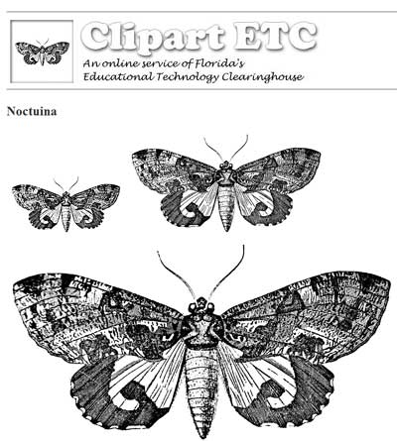

**My 4-H**

**Planning Calendar**

|  |  |  |  |  |  |  |
| --- | --- | --- | --- | --- | --- | --- |
| **Sunday** | **Monday** | **Tuesday** | **Wednesday** | **Thursday** | **Friday** | **Saturday** |
|  |  |  |  | 1 | 2 | 3 |
| 4 | 5 | 6 | 7 | 8 | 9 | 10 |
| 11 | 12 | 13 | 14 | 15 | 16 | 17 |
| 18 | 19 | 20 | 21 | 22 | 23 | 24 |
| 25 | 26 | 27 | 28 | 29 | 30 |  |



**September 2016**

|  |  |  |  |  |  |  |
| --- | --- | --- | --- | --- | --- | --- |
| **Sunday** | **Monday** | **Tuesday** | **Wednesday** | **Thursday** | **Friday** | **Saturday** |
|  |  |  |  |  |  | 1 |
| 2 | 3 | 4 | 5 | 6 | 7 | 8 |
| 9 | 10 | 11 | 12 | 13 | 14 | 15 |
| 16 | 17 | 18 | 19 | 20 | 21 | 22 |
| 23 | 24 | 25 | 26 | 27 | 28 | 29 |
| 30 | 31 |  |  |  |  |  |



C:\Program Files (x86)\Microsoft Office\MEDIA\CAGCAT10\j0305493.wmf

**October 2016**

|  |  |  |  |  |  |  |
| --- | --- | --- | --- | --- | --- | --- |
| **Sunday** | **Monday** | **Tuesday** | **Wednesday** | **Thursday** | **Friday** | **Saturday** |
|  |  | 1 | 2 | 3 | 4 | 5 |
| 6 | 7 | 8 | 9 | 10 | 11 | 12 |
| 13 | 14 | 15 | 16 | 17 | 18 | 19 |
| 20 | 21 | 22 | 23 | 24 | 25 | 26 |
| 27 | 28 | 29 | 30 |  |  |  |



**November 2016**



|  |  |  |  |  |  |  |
| --- | --- | --- | --- | --- | --- | --- |
| **Sunday** | **Monday** | **Tuesday** | **Wednesday** | **Thursday** | **Friday** | **Saturday** |
|  |  |  |  | 1 | 2 | 3 |
| 4 | 5 | 6 | 7 | 8 | 9 | 10 |
| 11 | 12 | 13 | 14 | 15 | 16 | 17 |
| 18 | 19 | 20 | 21 | 22 | 23 | 24 |
| 25 | 26 | 27 | 28 | 29 | 30 | 31 |



**December 2016**





|  |  |  |  |  |  |  |
| --- | --- | --- | --- | --- | --- | --- |
| **Sunday** | **Monday** | **Tuesday** | **Wednesday** | **Thursday** | **Friday** | **Saturday** |
| 1 | 2 | 3 | 4 | 5 | 6 | 7 |
| 8 | 9 | 10 | 11 | 12 | 13 | 14 |
| 15 | 16 | 17 | 18 | 19 | 20 | 21 |
| 22 | 23 | 24 | 25 | 26 | 27 | 28 |
| 29 | 30 | 31 |  |  |  |  |

**January 2017**



|  |  |  |  |  |  |  |
| --- | --- | --- | --- | --- | --- | --- |
| **Sunday** | **Monday** | **Tuesday** | **Wednesday** | **Thursday** | **Friday** | **Saturday** |
|  |  |  | 1 | 2 | 3 | 4 |
| 5 | 6 | 7 | 8 | 9 | 10 | 11 |
| 12 | 13 | 14 | 15 | 16 | 17 | 18 |
| 19 | 20 | 21 | 22 | 23 | 24 | 25 |
| 26 | 27 | 28 |  |  |  |  |

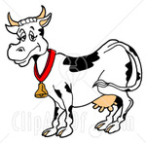

**February 2017**

|  |  |  |  |  |  |  |
| --- | --- | --- | --- | --- | --- | --- |
| **Sunday** | **Monday** | **Tuesday** | **Wednesday** | **Thursday** | **Friday** | **Saturday** |
|  |  |  | 1 | 2 | 3 | 4 |
| 5 | 6 | 7 | 8 | 9 | 10 | 11 |
| 12 | 13 | 14 | 15 | 16 | 17 | 18 |
| 19 | 20 | 21 | 22 | 23 | 24 | 25 |
| 26 | 27 | 28 | 29 | 30 | 31 |  |

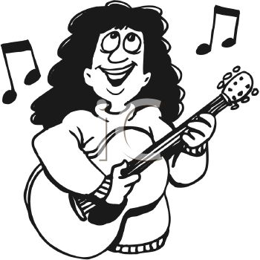

**March 2017**

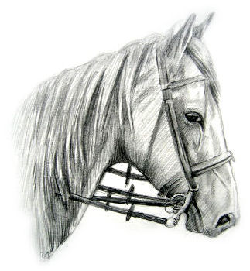

|  |  |  |  |  |  |  |
| --- | --- | --- | --- | --- | --- | --- |
| **Sunday** | **Monday** | **Tuesday** | **Wednesday** | **Thursday** | **Friday** | **Saturday** |
|  |  |  |  |  |  | 1 |
| 2 | 3 | 4 | 5 | 6 | 7 | 8 |
| 9 | 10 | 11 | 12 | 13 | 14 | 15 |
| 16 | 17 | 18 | 19 | 20 | 21 | 22 |
| 23 | 24 | 25 | 26 | 27 | 28 | 29 |
| 30 |  |  |  |  |  |  |



**April 2017**



|  |  |  |  |  |  |  |
| --- | --- | --- | --- | --- | --- | --- |
| **Sunday** | **Monday** | **Tuesday** | **Wednesday** | **Thursday** | **Friday** | **Saturday** |
|  | 1 | 2 | 3 | 4 | 5 | 6 |
| 7 | 8 | 9 | 10 | 11 | 12 | 13 |
| 14 | 15 | 16 | 17 | 18 | 19 | 20 |
| 21 | 22 | 23 | 24 | 25 | 26 | 27 |
| 28 | 29 | 30 | 31 |  |  |  |



**May 2017**

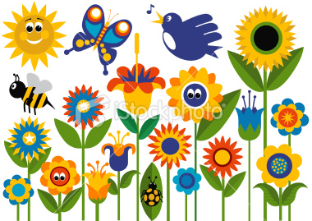

|  |  |  |  |  |  |  |
| --- | --- | --- | --- | --- | --- | --- |
| **Sunday** | **Monday** | **Tuesday** | **Wednesday** | **Thursday** | **Friday** | **Saturday** |
|  |  |  |  | 1 | 2 | 3 |
| 4 | 5 | 6 | 7 | 8 | 9 | 10 |
| 11 | 12 | 13 | 14 | 15 | 16 | 17 |
| 18 | 19 | 20 | 21 | 22 | 23 | 24 |
| 25 | 26 | 27 | 28 | 29 | 30 |  |



**June 2017**

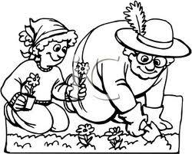

|  |  |  |  |  |  |  |
| --- | --- | --- | --- | --- | --- | --- |
| **Sunday** | **Monday** | **Tuesday** | **Wednesday** | **Thursday** | **Friday** | **Saturday** |
|  |  |  |  |  |  | 1 |
| 2 | 3 | 4 | 5 | 6 | 7 | 8 |
| 9 | 10 | 11 | 12 | 13 | 14 | 15 |
| 16 | 17 | 18 | 19 | 20 | 21 | 22 |
| 23 | 24 | 25 | 26 | 27 | 28 | 29 |
| 30 | 31 |  |  |  |  |  |



**July 2017**





|  |  |  |  |  |  |  |
| --- | --- | --- | --- | --- | --- | --- |
| **Sunday** | **Monday** | **Tuesday** | **Wednesday** | **Thursday** | **Friday** | **Saturday** |
|  |  | 1 | 2 | 3 | 4 | 5 |
| 6 | 7 | 8 | 9 | 10 | 11 | 12 |
| 13 | 14 | 15 | 16 | 17 | 18 | 19 |
| 20 | 21 | 22 | 23 | 24 | 25 | 26 |
| 27 | 28 | 29 | 30 | 31 |  |  |

**August 2017**

# PROJECT RECORD

*Use these next four pages for each project. Make extra copies as needed and insert.*

This 4-H project name is:

**______________________________________________________________________**

# PROJECT PLANS

I chose this project because:

**__________________________________________________________________________________________________________________________________________________________________________________________________________________**

Some of the things I want to do or learn in my 4-H project this year are: **__________________________________________________________________________________________________________________________________________________________________________________________________________________**

This is how I plan to finance my project:

**__________________________________________________________________________________________________________________________________________________________________________________________________________________**





Member Signature: _____________________________________________________

Leader Signature: ______________________________________________________

**Project Record page 1**



# PROJECT JOURNAL

|  |  |
| --- | --- |
| Timeline | How was my project done or made? |
|  |  |
|  |  |
|  |  |
|  |  |
|  |  |
|  |  |
|  |  |
|  |  |
|  |  |
|  |  |
|  |  |
|  |  |
|  |  |
|  |  |
|  |  |
|  |  |
|  |  |
|  |  |
|  |  |
|  |  |

**Project Record page 2**

____________________________________________________________________________________________________________________________________________

# What award did it receive at fair? How could I make it better or do differently for next year?

______________________________________________________________________

**Animal Identification Section *(if applies)*:**

Type of animal: _______________________ Breed: ___________________________

#### Identification marks or markings: __________________________________________

#### ____________________________________________________________________________________________________________________________________________

### PICTURES OR DRAWINGS OF PROJECT:

**Project Record page 3**



**What did I use? How much did I use? How much did it cost?**

# PROJECT RELATED MATERIALS

|  |  |
| --- | --- |
| Cost | Materials and what they were used for. |
|  |  |
|  |  |
|  |  |
|  |  |
|  |  |
|  |  |
|  |  |
|  |  |
|  |  |
|  |  |
|  |  |
|  |  |
|  |  |
|  |  |
|  |  |
|  |  |
|  |  |
|  |  |

[](http://www.designedtoat.com/clipart5/garden_07.g)

**Project Record page 4**

*Use this section of the booklet to record your participation in:*



# My 4-H Activities

This section is optional for Primary and Junior levels.

☺ Club offices & committees

☺ Judging

☺ Public presentations

☺ Contests

☺ Other 4-H events

☺ Community service

☺ 4-H promotions

☺ Family & home

☺ Leadership

☺ Non 4-H contests

☺ School & community activities

☺ 4-H awards & honors

☺ Club meeting attendance

##### Club Office and Committees

|  |  |
| --- | --- |
| **DATE** | OFFICE or COMMITTEE |
|  |  |
|  |  |
|  |  |
|  |  |
|  |  |
|  |  |
|  |  |
|  |  |
|  |  |
|  |  |
|  |  |
|  |  |
|  |  |

**My 4-H Year Activities page 1**

[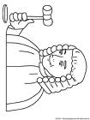](http://thecoloringspot.com/images/people/judge.j)

##### 4-H Judging

|  |  |  |  |
| --- | --- | --- | --- |
| DATE | **KIND OF JUDGING** | **NUMBER OF TIMES** | **AWARD** |
|  |  |  |  |
|  |  |  |  |
|  |  |  |  |
|  |  |  |  |
|  |  |  |  |
|  |  |  |  |
|  |  |  |  |

**4-H Contests**



|  |  |
| --- | --- |
| PROJECT SHOWN | NUMBER OF TIMES |
|  |  |
|  |  |
|  |  |
|  |  |
|  |  |
|  |  |
|  |  |



**4-H Public Presentations/Demonstrations**

|  |  |  |  |
| --- | --- | --- | --- |
| DATE | **TITLE OF PRESENTATION** | **NUMBER OF TIMES** | **AWARD** |
|  |  |  |  |
|  |  |  |  |
|  |  |  |  |
|  |  |  |  |
|  |  |  |  |
|  |  |  |  |
|  |  |  |  |

**My 4-H Year Activities page 2**



##### Other 4-H Events

*Examples: achievement program, talent show, camp, tours, etc.*

|  |
| --- |
| EVENT PARTICIPATION |
|  |
|  |
|  |
|  |
|  |
|  |
|  |
|  |
|  |
|  |
|  |

##### My Family & Home Activities



4-H feels that FAMILY and HOME activities are very important! Please list special things you did with your family; such as, jobs you worked on, chores, family reunions, camping trips, vacations or other special events that shows you were a part of the family action.



|  |  |
| --- | --- |
| **DATE** | ACTIVITY |
|  |  |
|  |  |
|  |  |
|  |  |
|  |  |
|  |  |
|  |  |
|  |  |
|  |  |

**My 4-H Year Activities page 3**

##### Community Service



*Activities or service I helped my club do for my town or community*

|  |  |
| --- | --- |
| **DATE** | ACTIVITY |
|  |  |
|  |  |
|  |  |
|  |  |
|  |  |
|  |  |
|  |  |
|  |  |
|  |  |
|  |  |
|  |  |



##### 4-H Promotion

Talks or displays I made about 4-H

*Talks, posters, window displays, radio, news stories*

|  |  |  |
| --- | --- | --- |
| **DATE** | **ACTIVITY** | **WHERE** |
|  |  |  |
|  |  |  |
|  |  |  |
|  |  |  |
|  |  |  |
|  |  |  |
|  |  |  |
|  |  |  |
|  |  |  |
|  |  |  |
|  |  |  |
|  |  |  |



**My 4-H Year Activities page 4**



##### School & Community

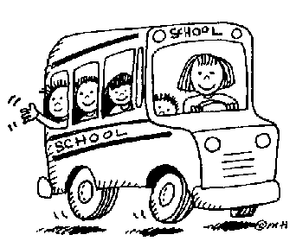

*Things I did in school, town, church, and other groups*

|  |  |
| --- | --- |
| **DATE** | **ACTIVITY** |
|  |  |
|  |  |
|  |  |
|  |  |
|  |  |
|  |  |
|  |  |
|  |  |
|  |  |



##### My Top 4-H Awards & Honors

|  |  |
| --- | --- |
| **DATE** | **MOST IMPORTANT RECOGNITION DURING THE 4-H YEAR** |
|  |  |
|  |  |
|  |  |
|  |  |
|  |  |
|  |  |
|  |  |



##### Club Meeting Attendance

|  |  |
| --- | --- |
| YEAR |  |
| **NUMBER OF MEETINGS HELD** |  |
| **NUMBER ATTENDED** |  |

**My 4-H Year Activities page 5**

[](http://www.dentonisd.org/530201015115959723/lib/530201015115959723/Eagle_clip_art.j)

##### Leadership

*How I helped others with their projects*

|  |  |  |
| --- | --- | --- |
| **Date** | **ACTIVITY** | WHERE |
|  |  |  |
|  |  |  |
|  |  |  |
|  |  |  |
|  |  |  |
|  |  |  |
|  |  |  |
|  |  |  |
|  |  |  |
|  |  |  |

##### Contests I attended that were not 4-H

|  |  |  |
| --- | --- | --- |
| **Date** | **CONTEST** | NUMBER OF TIMES |
|  |  |  |
|  |  |  |
|  |  |  |
|  |  |  |
|  |  |  |
|  |  |  |
|  |  |  |
|  |  |  |
|  |  |  |
|  |  |  |
|  |  |  |
|  |  |  |

**My 4-H Year Activities page 6**





[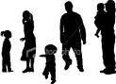](http://www1.istockphoto.com/file_thumbview_approve/485308/2/istockphoto_485308_family_silhouette.j)

# MY 4-H STORY

Some things about my family and me are …

________________________________________________________________________________________________________________________________________________________________________________________________________________________________________________________________________________________________________________________________________________________________________________________________________________________________________________________________________________________________________________________________________________________________________________

I participated in 4-H this year because … __________________________________________________________________________________________________________________________________________________________________________________________________________________________________________________________________________________________________________________________________________________________________________________________________________________________________________________________________________________________________________

______________________________________________________________________

My favorite things in 4-H this year …

______________________________________________________________________ ________________________________________________________________________________________________________________________________________________________________________________________________________________________________________________________________________________________

[](http://www1.istockphoto.com/file_thumbview_approve/4964677/2/istockphoto_4964677_environmental_awareness_illustration_north_america.j)_____________________________________________________________________________________________________________________________________________________________________________________________________________

_____________________________________________________________________

**My 4-H Story page 1**

[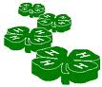](http://www.umext.maine.edu/piscataquis/4hpages/4-h3dxsm.g)

How I changed because of my 4-H project and club experience …

____________________________________________________________________________________________________________________________________________________________________________________________________________________________________________________________________________________________________________________________________________________________________________________________________________________________________________________________________________________________________________________________________________________________________________________________________________________________________________________________________________________________________________________________

______________________________________________________________________

[](http://www.dreamstime.com/abstract-dragonfly-clip-art-thumb2807035.j)______________________________________________________________________

_______________________________________________________________________________________________________________________________________________________________________________________________________________

________________________________________________________________________________________________________________________________________________________________________________________________________________________________________________________________________________________________________________________________________________________________________________________________________________________________________________________________________________________________________________________________________________________________________________ ______________________________________________________________________________________________________________________________________________________________________________________________________________________________________________________________________________________________________________________________________________________________



**My 4-H Story page 2**

[](http://school.discoveryeducation.com/clipart/images/schoolnews.g)Paste any pictures of you, your club, drawings, newspaper clippings, letters, awards, or anything related to you and your club or 4-H project.

# My 4-H MEMORIES





**My 4-H Memories page 1**

**THE 4-H PLEDGE**

"I pledge

My **Head** to clearer thinking,   
My **Heart** to greater loyalty,   
My **Hands** to larger service,   
My **Health** to better living,

For my club, my community, my country, and my world"

As a 4-H teen, you can look forward to:

* Teen Conferences
* Know Your Government
* Interstate Exchange
* International Exchange
* District Teen Rally
* Maybe even a trip to WA D.C.
* and many other upcoming activities

**Scholarships are available for many activities!**

*Washington State University Extension helps people develop leadership skills and gives them research-based knowledge to improve their economic status and quality of life, cooperative agencies Washington State University, U.S. Department of Agriculture, and Wahkiakum County. Extension programs and policies are consistent with federal and state laws and regulations on nondiscrimination regarding race, sex, religion, age, color, creed, national or ethnic origin; physical, mental or sensory disability; marital status, sexual orientation, or status as a Vietnam-era or disabled veteran. Evidence of noncompliance may be reported through your local Extension office.*