310 N. Main, Room 209, Colfax, WA 99111 (509) 397-6290 ~ Phone (509) 397-6256 ~ Fax

Western Whitman County
Field Program

Thursday, June 8, 2017 8:30 am
LaCrosse, WA

Time | Topic | Location | Speaker
8:30 | Donuts & Coffee  Introductions | McGregor Plant, LaCrosse, WA | Steve Van Vleet, WSU/Whitman County Extension
9:00 - 10:00 | Uniform Cereal Variety Testing  Program | Bob Morasch Farm | Ryan Higginbotham
10:00 - 11:00 | Stripe rust effects in 2017, Fungicide control measures to be used to control stripe rust and soil pests in small grains | Bob Morasch Farm | Dr. Tim Murray
11:00 - 12:00 | Insect and weed issues on the rise and management options | Bob Morasch Farm | Dr. Drew Lyon
12:30 | LUNCH | LaCrosse City Park | Sponsored by McGregor Company

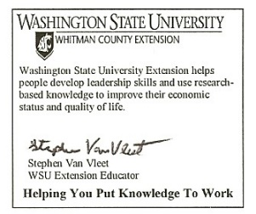
Approval Pending for Pesticide Recertification Credits

For more information contact Steve Van Vleet at
(509) 397-6290 or svanvleet@wsu.edu

Cooperating agencies: Washington State University, U.S. Department of Agriculture, and Whitman County Extension programs and employment are available to all without discrimination. Evidence of noncompliance may be reported through your local Extension office.

