
King County 4-H

Record Book

Decorate or place picture related to your project
Name: __________________________________________ 4-H Calendar Year: 20___ to 20___
4-H age: _____ as of October 1 this 4-H year
Number of years in 4-H ______
Age Division (by October 1 of this 4-H year):
□ Cloverbud (ages 5-7)
□ Junior (ages 8-10)
□ Intermediate (ages 11-13)
□ Senior (ages 14-not yet 19)
________________________________________________________________________________
4-H Club

Project(s)

Instructions
- Complete entire Record Book with at least one project record. See table of contents for book order.
- Complete additional 4-H Project record as needed- one for each enrolled 4-H project.
- Complete and include the 4-H Permanent Record (included in this county record book or the state separate file version, C0933)
- For Cloverbud members (ages 5-7), record books are optional at the county level and not judged!
- For year-end completion, ENTIRE record book must be completed.
- The 4-H member should complete this record book to the best of their ability.
- To request official accommodations, please contact your leader or the Extension office

Describe any accommodations you used while completing the record book here if you would like the judge to be aware (optional):

WSU 4-H Youth Development is committed to providing safe and inclusive environments for all youth and adults regardless of race; sex; gender; sexual orientation; gender identity; gender expression; religion; age; color; creed; national or ethnic origin; citizenship; physical, mental, or sensory ability; genetic information; and/or status as an honorably discharged veteran or member of the military. Evidence of noncompliance may be reported through your local Extension office.

Table of Contents
Please put your 4-H Record Book in the order listed below.
Table of Contents
Instructions 2
Table of Contents 3
4-H Calendar/Activity Log 4
4-H Project Record 8
Goal Setting 9
Project Goals 10
Project Inventory 14
Budget 15
Reflection 16
Public Presentations 17
Project Photos and Memories 18
Project Photos and Memories Cont. 19
My 4-H Story 20
My 4-H Story continued 21
My 4-H Story continued 22
4-H Life Skills Wheel 23
4-H Life Skills Reflection 24
4-H Permanent Record 25

4-H Calendar/Activity Log
List all 4-H meetings, club and county events, and project activities. You may group similar activities by month. Example: June- Attended 3 Horse project workdays. If you did not attend any events in a month, please write “NONE.” Notes are optional. Include year in dates.

OCTOBER
Date(s) | Meeting/Activity/Event | Notes

NOVEMBER
Date(s) | Meeting/Activity/Event | Notes

DECEMBER
Date(s) | Meeting/Activity/Event | Notes

JANUARY
Date(s) | Meeting/Activity/Event | Notes

FEBRUARY
Date(s) | Meeting/Activity/Event | Notes

MARCH
Date(s) | Meeting/Activity/Event | Notes

APRIL
Date(s) | Meeting/Activity/Event | Notes

MAY
Date(s) | Meeting/Activity/Event | Notes

JUNE
Date(s) | Meeting/Activity/Event | Notes

JULY
Date(s) | Meeting/Activity/Event | Notes

AUGUST
Date(s) | Meeting/Activity/Event | Notes

SEPTEMBER
Date(s) | Meeting/Activity/Event | Notes


4-H Project Record
Project Cover Page

Complete one project record for each project. (No additional add sheets are required)
Name: ____________________________________
Current 4-H Year: __________________________
Project: ___________________________________
Number of years you have been in this project (including this year). __________
(If this is your first year, the number of years in the project is 1.)

This page is not complete without all signatures and dates

Member's Signature: ________________________ Date:____________
I declare that the information in this book is correct and that I completed all my club and 4-H requirements to the best of my knowledge. I did my own work in this record book.

Parent’s Signature: ________________________ Date:_____________
I declare my child completed this record book with minimal assistance.

Leader’s Signature: ________________________ Date:_____________
(GOALS) I declare this member has completed and shown me their goals for the upcoming 4-H year.
To be signed near the beginning of the 4-H year.

Leader’s Signature: ________________________ Date: _____________
(YEAR END) I declare this member has met all club requirements for year-end completion.

WSU 4-H Youth Development is committed to providing safe and inclusive environments for all youth and adults regardless of race; sex; gender; sexual orientation; gender identity; gender expression; religion; age; color; creed; national or ethnic origin; citizenship; physical, mental, or sensory ability; genetic information; and/or status as an honorably discharged veteran or member of the military. Evidence of noncompliance may be reported through your local Extension office.

Goal Setting
Setting goals is an important part of 4-H but can sometimes feel overwhelming. SMART goals help with organization, focus and breaking down large goals into smaller steps. They can help build confidence as realistic goals are set and you can celebrate the little steps and accomplishments that happen toward the larger goal along the way.
Use the graphic below to help you think about what you want to achieve by participating in your 4-H project(s), then fill out the project(s) goal sheet on the following page.
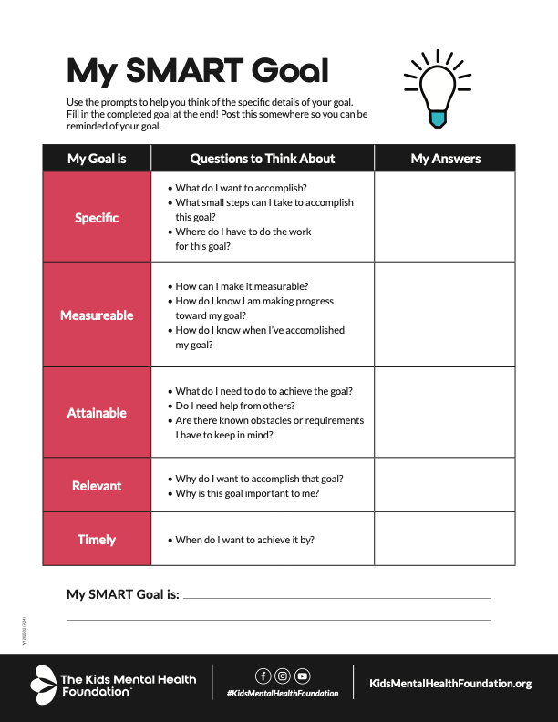
Graphic and information from The Kids Mental Health Foundation

Project Goals
Instructions: Think about what you want to achieve by participating in your 4-H Project(s). Set goals that are interesting to you. Identify goals with goal 1), 2), 3). After you decide on a goal, plan what you will need to do to reach your goal. Write if you experienced any problems, successes, and if there is anything you would do differently in the future. There is another version of a goal worksheet after the one below. Choose whichever you prefer best. Write in complete sentences!
Goal Requirements:
Cloverbuds and Juniors: 1 goal/project Intermediates- 2 goals/project Seniors-3 goals/project
EXAMPLE:
My goals (in box below) | Here is what I need to do to reach my goals.
1) I will memorize the parts of a goat by fair time. | 1) I will research the parts of a goat and lead a game at my 4-H meeting to help others practice.

My Goal(s):
Here is what I need to do to reach my goal(s):
Did you have any problems reaching your goals?
What successes did you have while working toward these goals?
Based on what you know now, if you could go back to the beginning of the 4-H year and start over, what would you do differently to reach these goals?
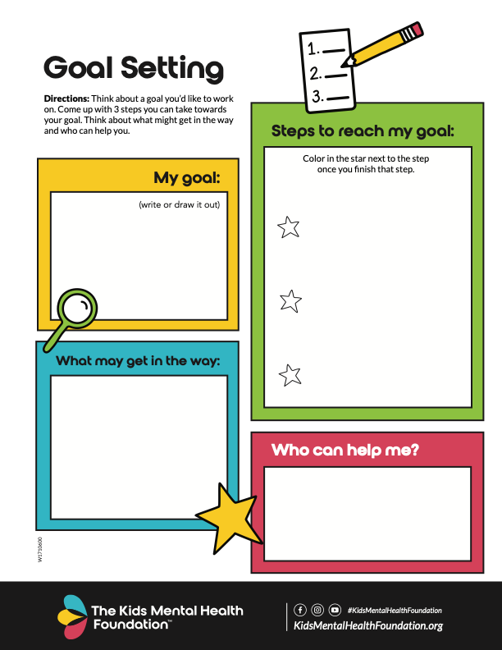

Project Inventory
Keep a record of any supplies you have on hand or purchase for your project. This inventory can be used for animals or non-animal projects. Examples of items are cages, grooming and medical supplies, feed, animals/pets, ingredients, crafting supplies, etc. Anything used for your project can count. If you aren’t sure the value of some of your equipment or supplies, do some research and find similar items to yours.
Item | Number | Value | Notes

Budget
Making a budget for your project helps you determine approximately how much it is going to cost. One column is for estimated budget. These are not your actual expenses, but only what you think your expenses are going to be. You may not have expenses in each category. Preparing a budget allows you to financial prepare and plan for your project, especially if it involves animals. The other column is for your actual budget. Please complete that column from your project records/receipts. You are not expected to have an income or earn profit from your project.
Expenses | Estimated ($) | Actual ($) | Difference ($)
Total

Example:
If your estimated feed cost was $50 and your actual feed cost was $65:
$65 − $50 = +$15
Record +$15 in the Difference column. This means you spent $15 more than estimated.

Reflection:
- Which expenses were closest to your estimate?
- Which expenses were higher or lower than expected?
- What did you learn about planning a budget for your project?
- What would you do differently next year?
Write your answers to these questions in the space below. You do not have to answer all of them. This is a space to reflect on your budgeting!

Project Area
Presentation Title
Type | ☐ Illustrated Talk ☐ Demonstration ☐ Speech ☐ Other

Public Presentations
You should aim to do at least one public presentation per 4-H year related to your project. Use the worksheet below to help plan your presentation. Visit WSU Publications EM4788E and EM4787E for more information.
Hook/Introduction:

Purpose:

Main Point | Notes
1

2

3
Conclusion:

Sources:

Location | Award/Placing | Comments
Club
Fair
State
Other

Project Photos and Memories
Use the pages below to attach photos related to this 4-H project. You can also draw them if you prefer.

Project Photos and Memories Cont.

My 4-H Story
Instructions:
- Complete your 4-H Story on a separate piece of paper. Stories may be typed or handwritten.
- Length Requirements:
  - Cloverbuds (optional): At least 1 paragraph
  - Juniors - At least 3 paragraphs
  - Intermediates and Seniors - At least 5 paragraphs.
- Include an introduction, body, and conclusion.
- Complete your 4-H story for year-end completion and awards.

Let your creativity help you tell your 4-H story in a unique way. Here are some ideas to help guide your writing:
- Introduction: Talk about yourself, your name and club, your projects, number of years in 4-H.

- Body: What did you do in 4-H this year? What special events did you attend?
Write about your projects and describe your experiences with leadership and community service. Write about what your club did and if/how you participated. What did you learn in 4-H this year? What did you enjoy most? What was your greatest accomplishment? How has 4-H affected your life?
- Conclusion: What are your future plans in 4-H? How will you apply what you learned this year to your life?
You may include non-4-H activities and accomplishments but try to focus on your 4-H experiences.

Start writing on the next page

My 4-H Story continued

My 4-H Story continued

4-H Life Skills Wheel
Use this wheel to complete the following Life Skills Page.

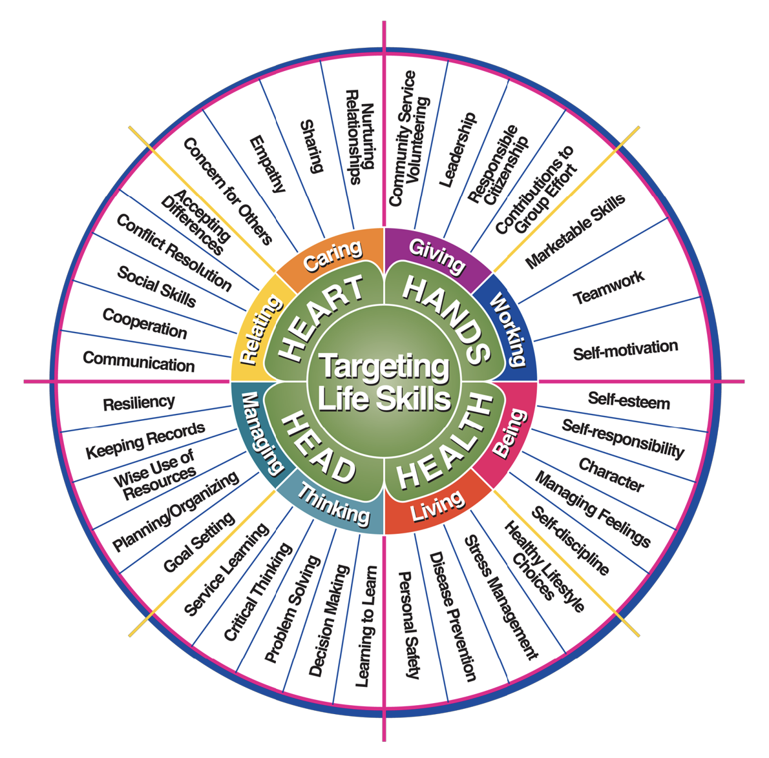
Iowa State University Extension – Targeting Life Skills Model, 1996

4-H Life Skills Reflection
In 4-H, youth develop life skills related to the 4 “H”s: Head, Heart, Hands and Health. Using the Life Skill Wheel on the previous page, identify at least one life skill per “H” that you have learned in 4-H. In the boxes below, describe how you have learned and practiced each life skill selected.
Example:
Head- Goal Setting – I set a goal to practice fitting and showing two times a week with my rabbit
HANDS

HEART

HEALTH

HEAD

4-H Permanent Record
Instructions: Make at least one entry per year in each section. If you do not have something to include for that section, at minimum enter the year and write “none”. For example, “17-18” “none.” Keep this section every year you are in 4-H and add pages as needed. This is your 4-H “resume”.
Name: __________________________________________________________________________
Date this record started: _________________ Date ending this record: _________________

Public Presentations: List all the demonstrations, illustrated talks, and public presentations you gave. List the related project, where given, and the award received. If presentation is non-project related please write “non.”
Year | Presentation Title | Project | Where | Award

Leadership Experiences: List your offices in 4-H, e.g., President, Vice President, etc. List any committees you work on each year. List any leadership activities you participated in. Describe if it is for your club or county, or state and what you did.
Year | Office/Committee/Activity | What Group | Duties Performed

Contests/Exhibits Entered: List all the contests you entered such as fitting and showing, kitchen activities, equitation or pleasure classes, judging, herdsmanship, educational displays at fairs, shooting events, record book contest, talent show, etc. Also list all Exhibits entered and placings. Mark an “x” if the contest was a 4-H contest. If the contest is non-project related, please right “non.”
Year | Contest/Exhibit Entered | Project | Where | Award | 4-H

Contests/Exhibits Entered (continued): Mark an “x” if the contest was a 4-H contest.
Year | Contest/Exhibit Entered | Project | Where | Award | 4-H

Community Service: List all the 4-H community services in which you participated. Be specific, such as volunteered at nursing home, cleaned county park, etc.
Year | What did you do? | Where

School and Community Responsibilities: List the activities you did at school, church, in sports or community events other than 4-H.
Year | Activity | Where

4-H Meeting Attendance: Record the total number of project meetings and general club meetings that you attended and the total number of general club meetings that were held.
Year | Number of project meetings attended | Number of general club meetings attended | Total number of general club meetings held

Most Important Recognition: List the most important recognition you received in 4-H during the year, such as honors, awards, trips, etc., and what project you were recognized for.
Year | Most Important Recognition | Project

